Designing Advanced Data Architecture for

Business Intelligence

**United States Health Insurance Program**

Project Report

Team Name: Mavericks

Team Members

1. Additya Dharangaonkar 001052304
2. Samarth Hadawale 001053811
3. Rohan Kapadnis 001342161

**Background:**

We have used a dataset that provides information on the health insurance coverage data for each US state and the nation as a whole. It includes entities of Issuer information, Network served, States covered, various Policies, Procedures included and the Claims applied. Total volume of the data extends to 250,000+ rows.

**Goal:**

* To explore the Health Insurance Programs offered in the US.
* Investigate the claims that are rejected or accepted by the Health Insurance plans
* Measure the amount of premium dollars that a Health Plan spends on medical claims and quality improvement
* Extract the information regarding the time required for claim settlement
* Determine the variance in plan benefits and rates across different US States.
* Measure the revenue that a Health Plan gains on medical claims

**ER Diagram:**

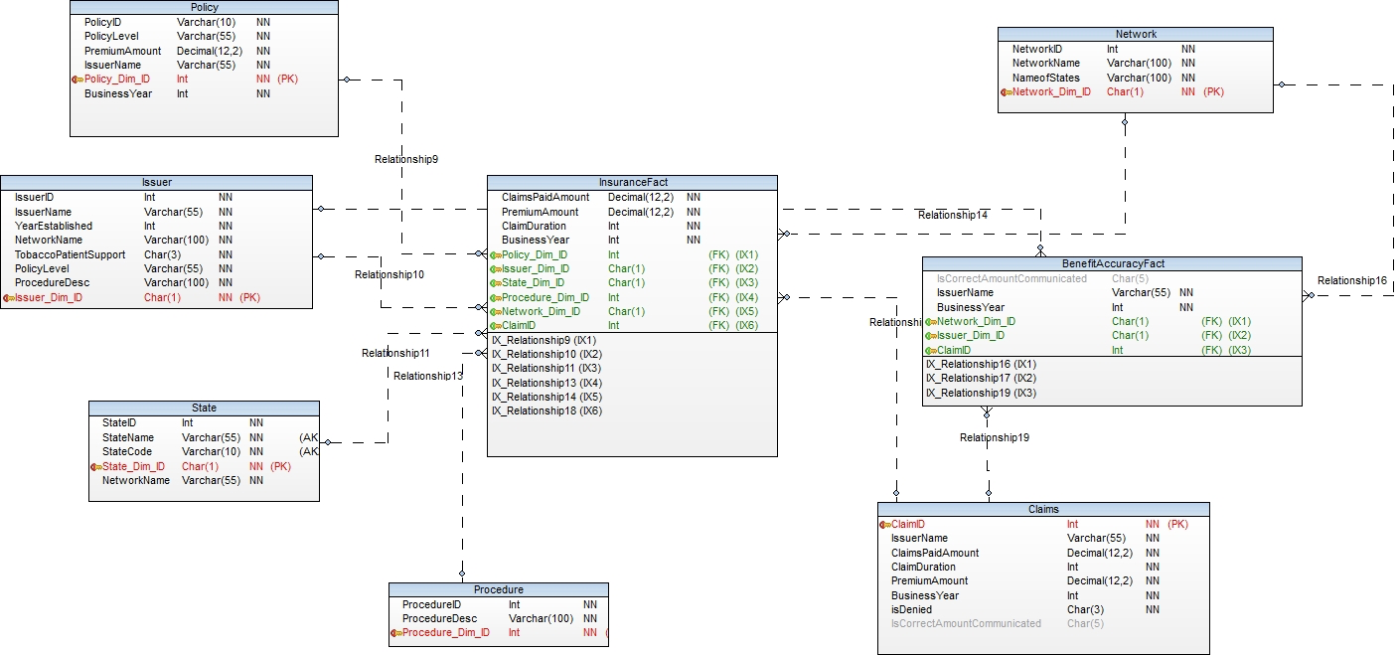

**KPI definitions:**

1. **Medical Loss Ratio:**

Medical Loss Ratio (MLR) measures the amount of money that a health insurance company spends paying out claims and improving the overall quality of care provided to their policyholders relative to total premium revenue (earned premium) over the same period of time.

**Formula** : (TotalClaimsPaidAmount/TotalPremiumEarned)*100

1. **Claim Settlement Cycle:**

Claim settlement cycle time measures the average amount of time required to settle and close an insurance claim, from first notice until settlement.

**Formula** : Sum of Claims Settlement Cycle Times/Total No. of Claims Settled

1. **Claim Denial Rate:**

Health Insurance Claims Denial Rate measures the percentage of medical claims submitted by policyholders that are denied by the insurance company.

**Formula :** (Number of Medical Claims Denials/Total Number of Medical Claims Adjudicated)*100

1. **Benefit Accuracy Rate:**

Benefit Accuracy Rate measures the percentage of instances where the health insurance company communicated the correct patient responsibility amount

**Formula :** (Number of Instances where Correct Patient Responsibility Amount was Communicated by Payer/Total Number of Patient Responsibility Amounts Communicated)*100

1. **Revenue of Issuers:**

Revenue is the income generated from normal business operations.

**Formula : (100*Sum of Claims Paid Amount)/85**

**Implementation:**

1. **Talend Jobs:**

* **a. Dimension Loading**

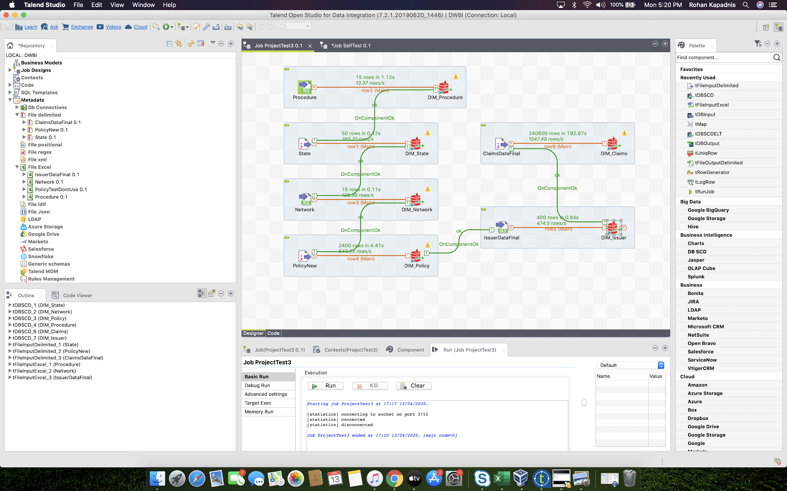

In this step, we have loaded our metadata, namely Procedure, State, Network, Policy, Claims and Issuer into the respective tDBSCD(Oracle) component.

* **b. Fact(1) creation : Benefit Accuracy**

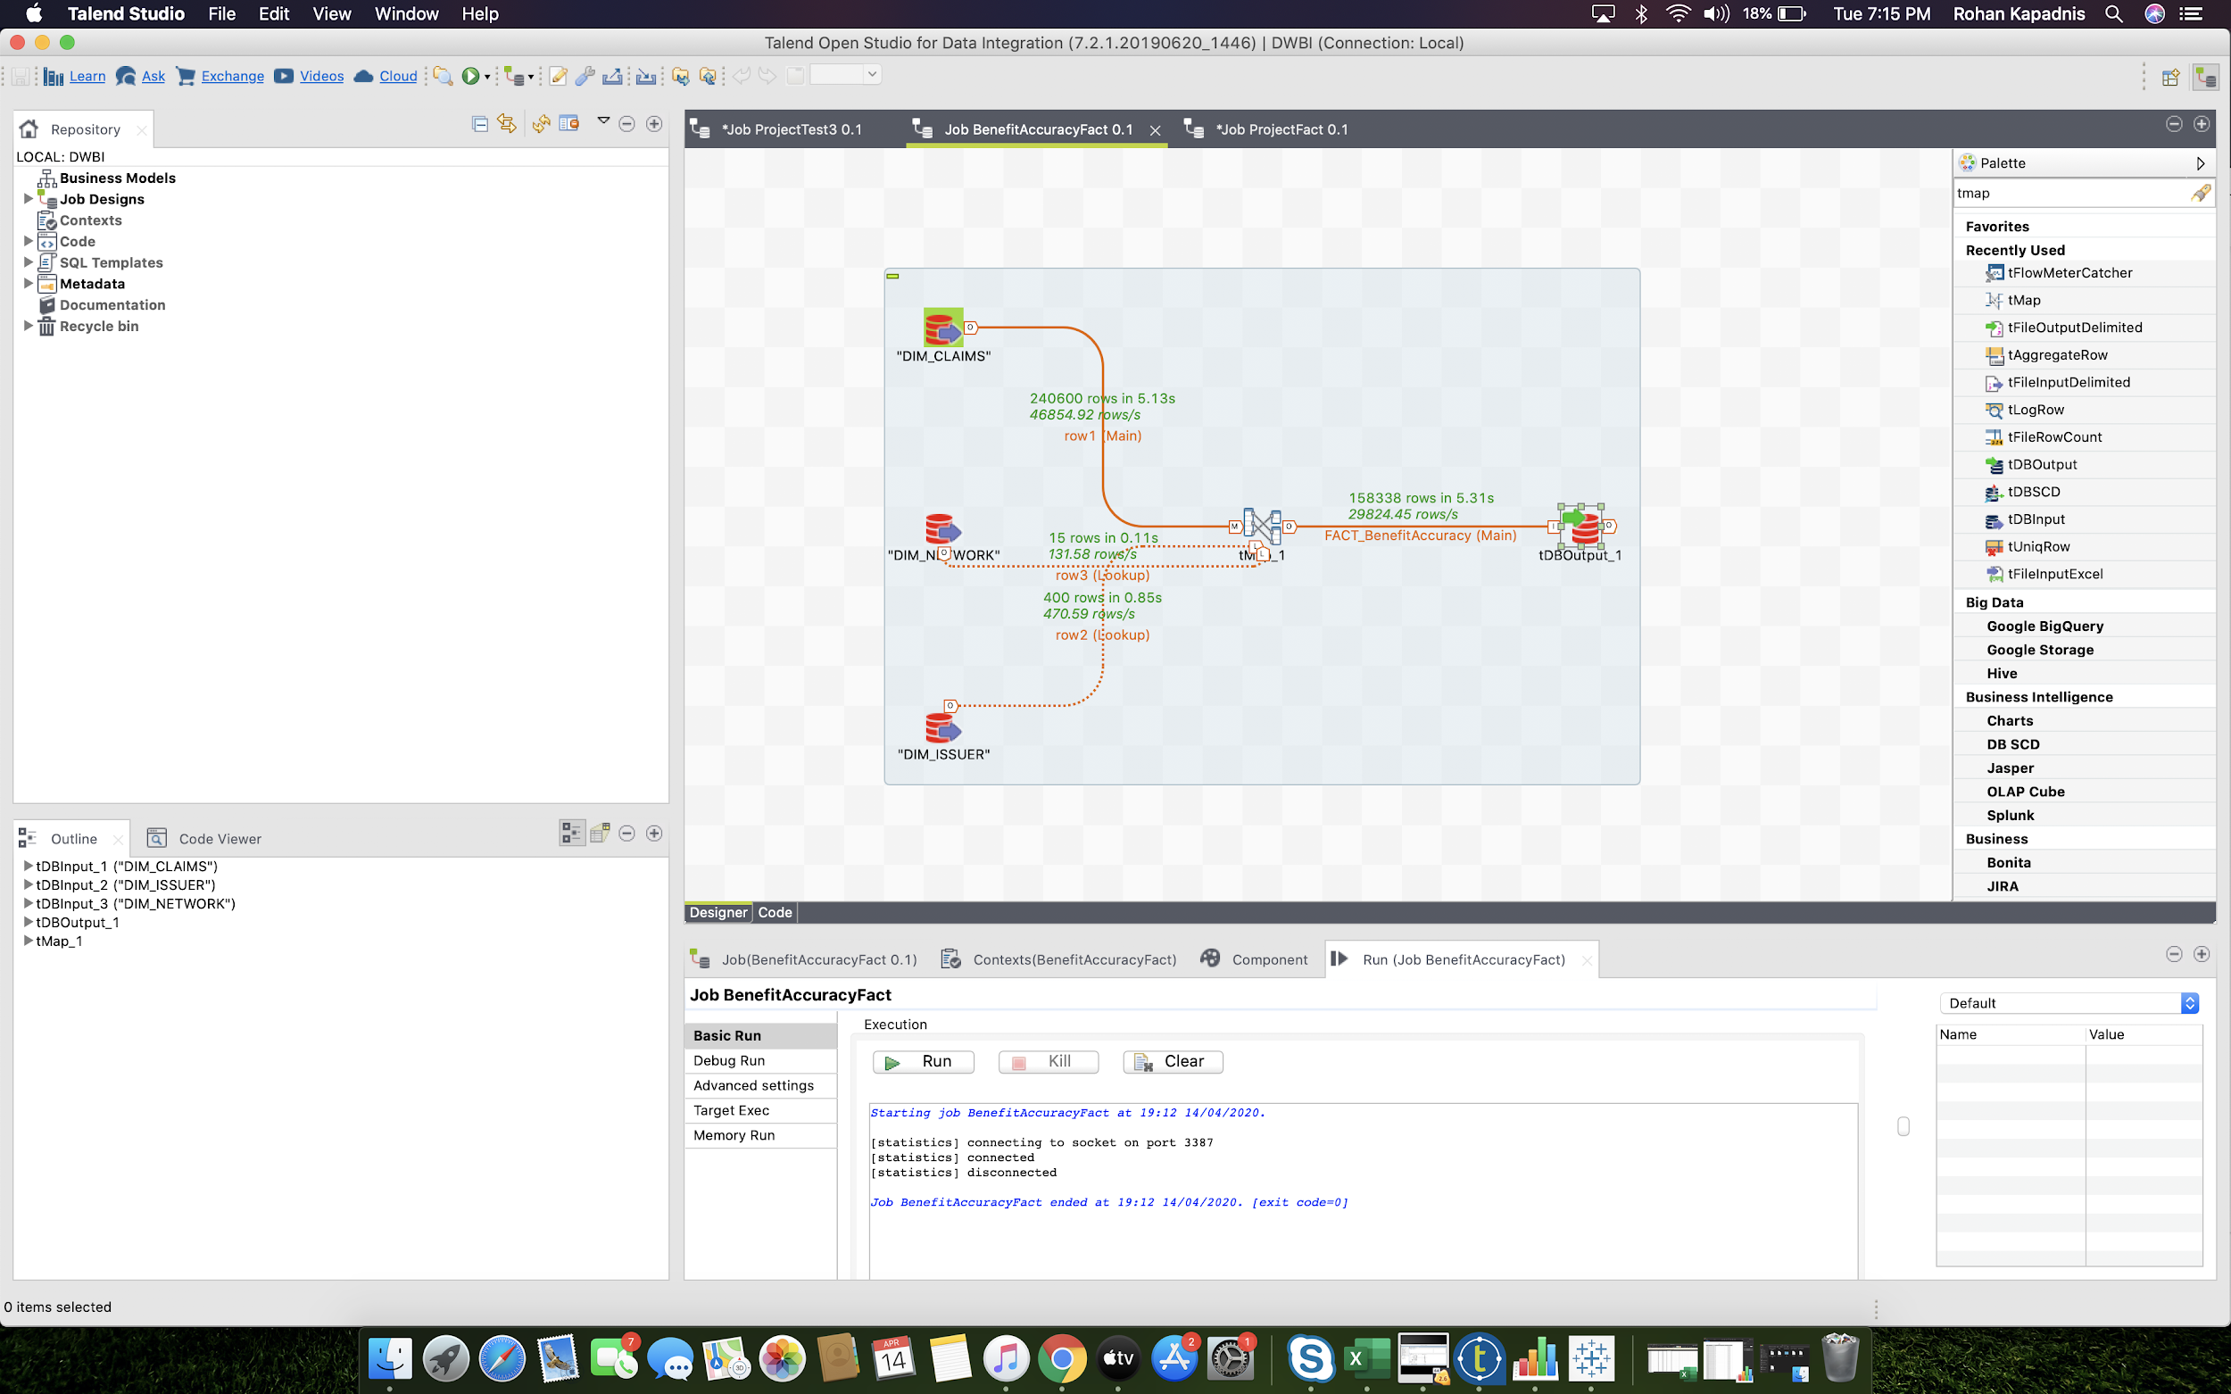

In this job, we have used the dimensions of Claims, Issuer and Network for the generation of the Fact Table : Benefit Accuracy.

* **c. Fact(2) creation : Insurance**

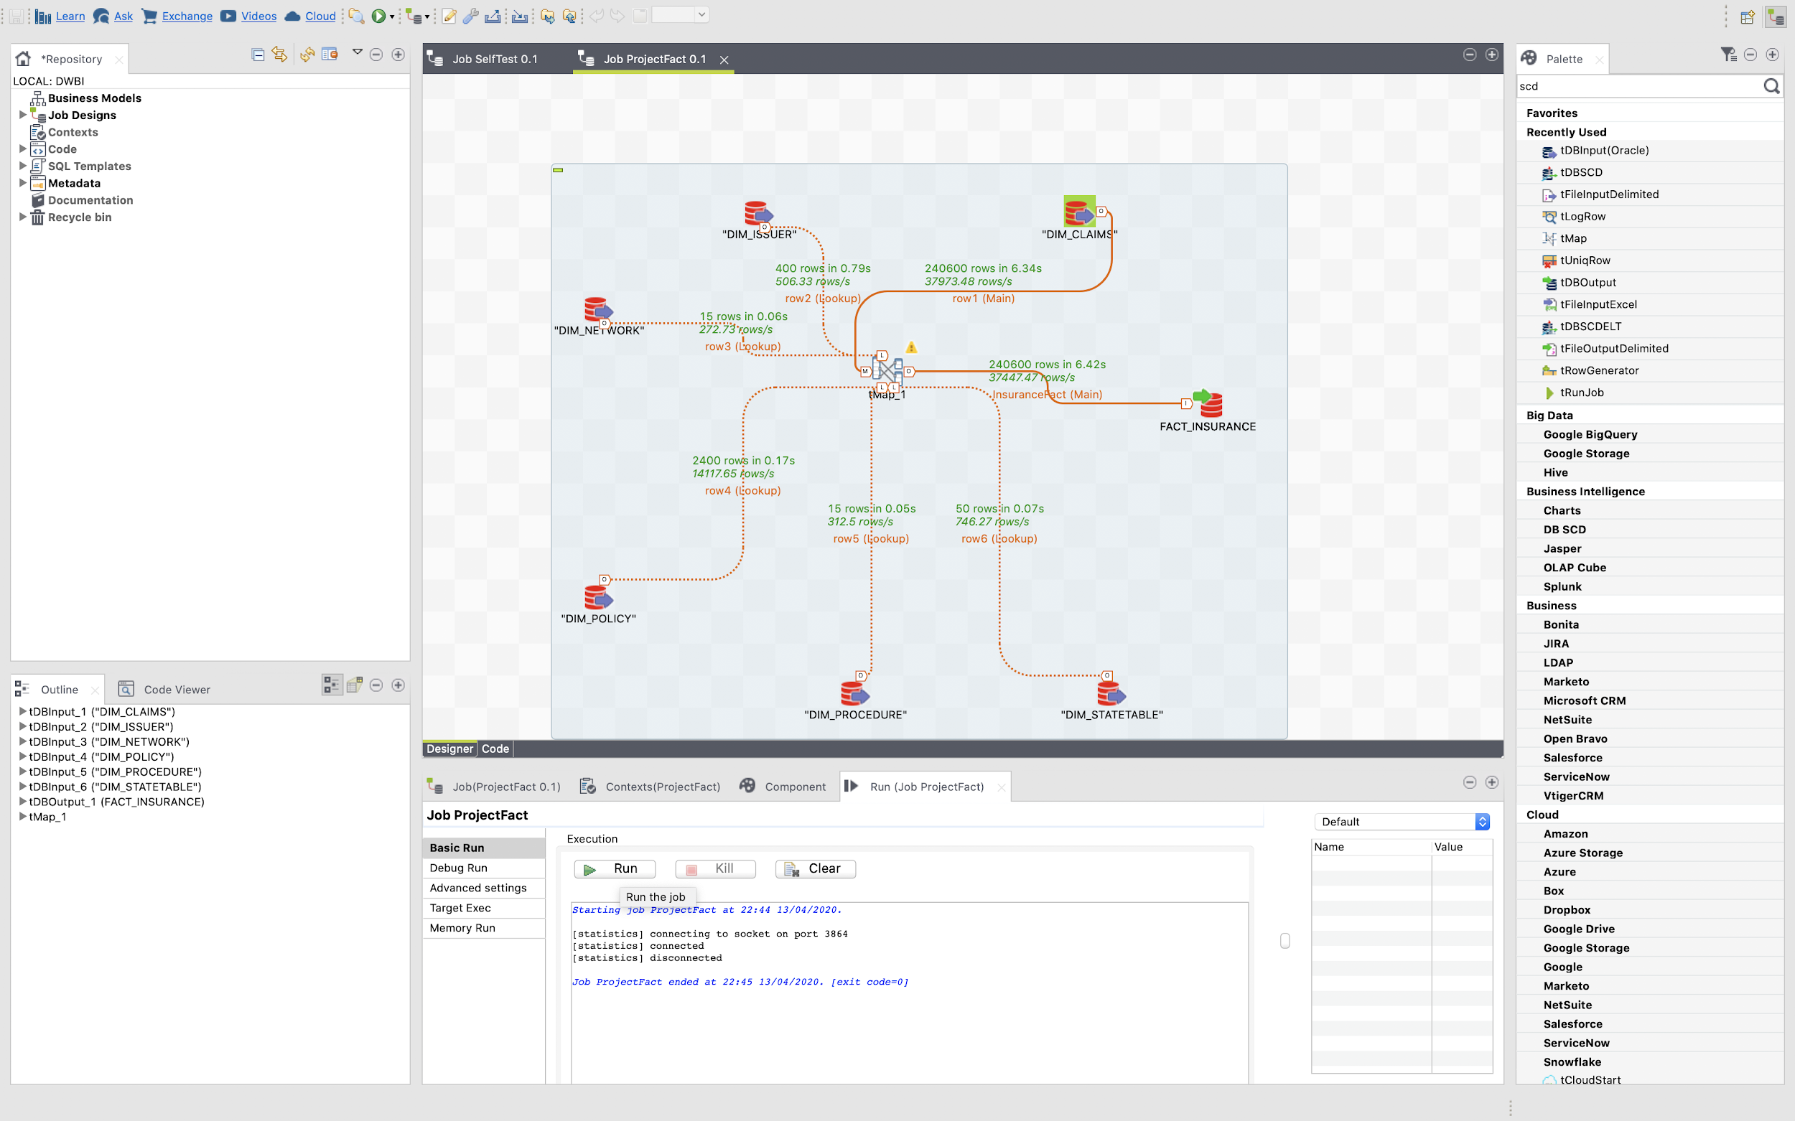

This job is for Insurance Fact Table creation.

1. **Databases**

* **a. Dimension Claims**

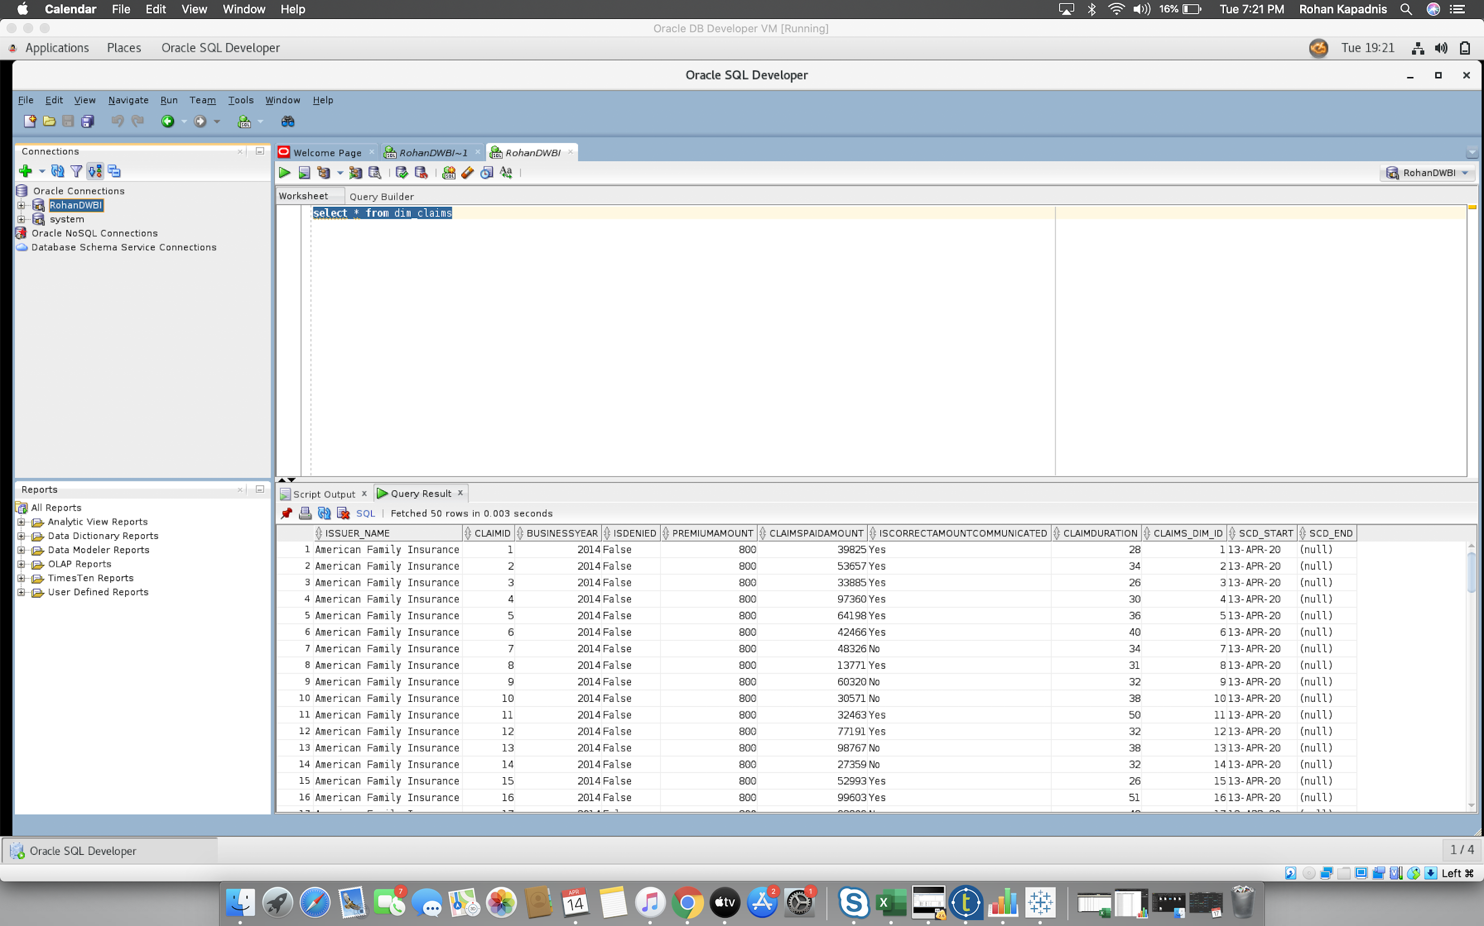

* **b. Dimension Issuer**

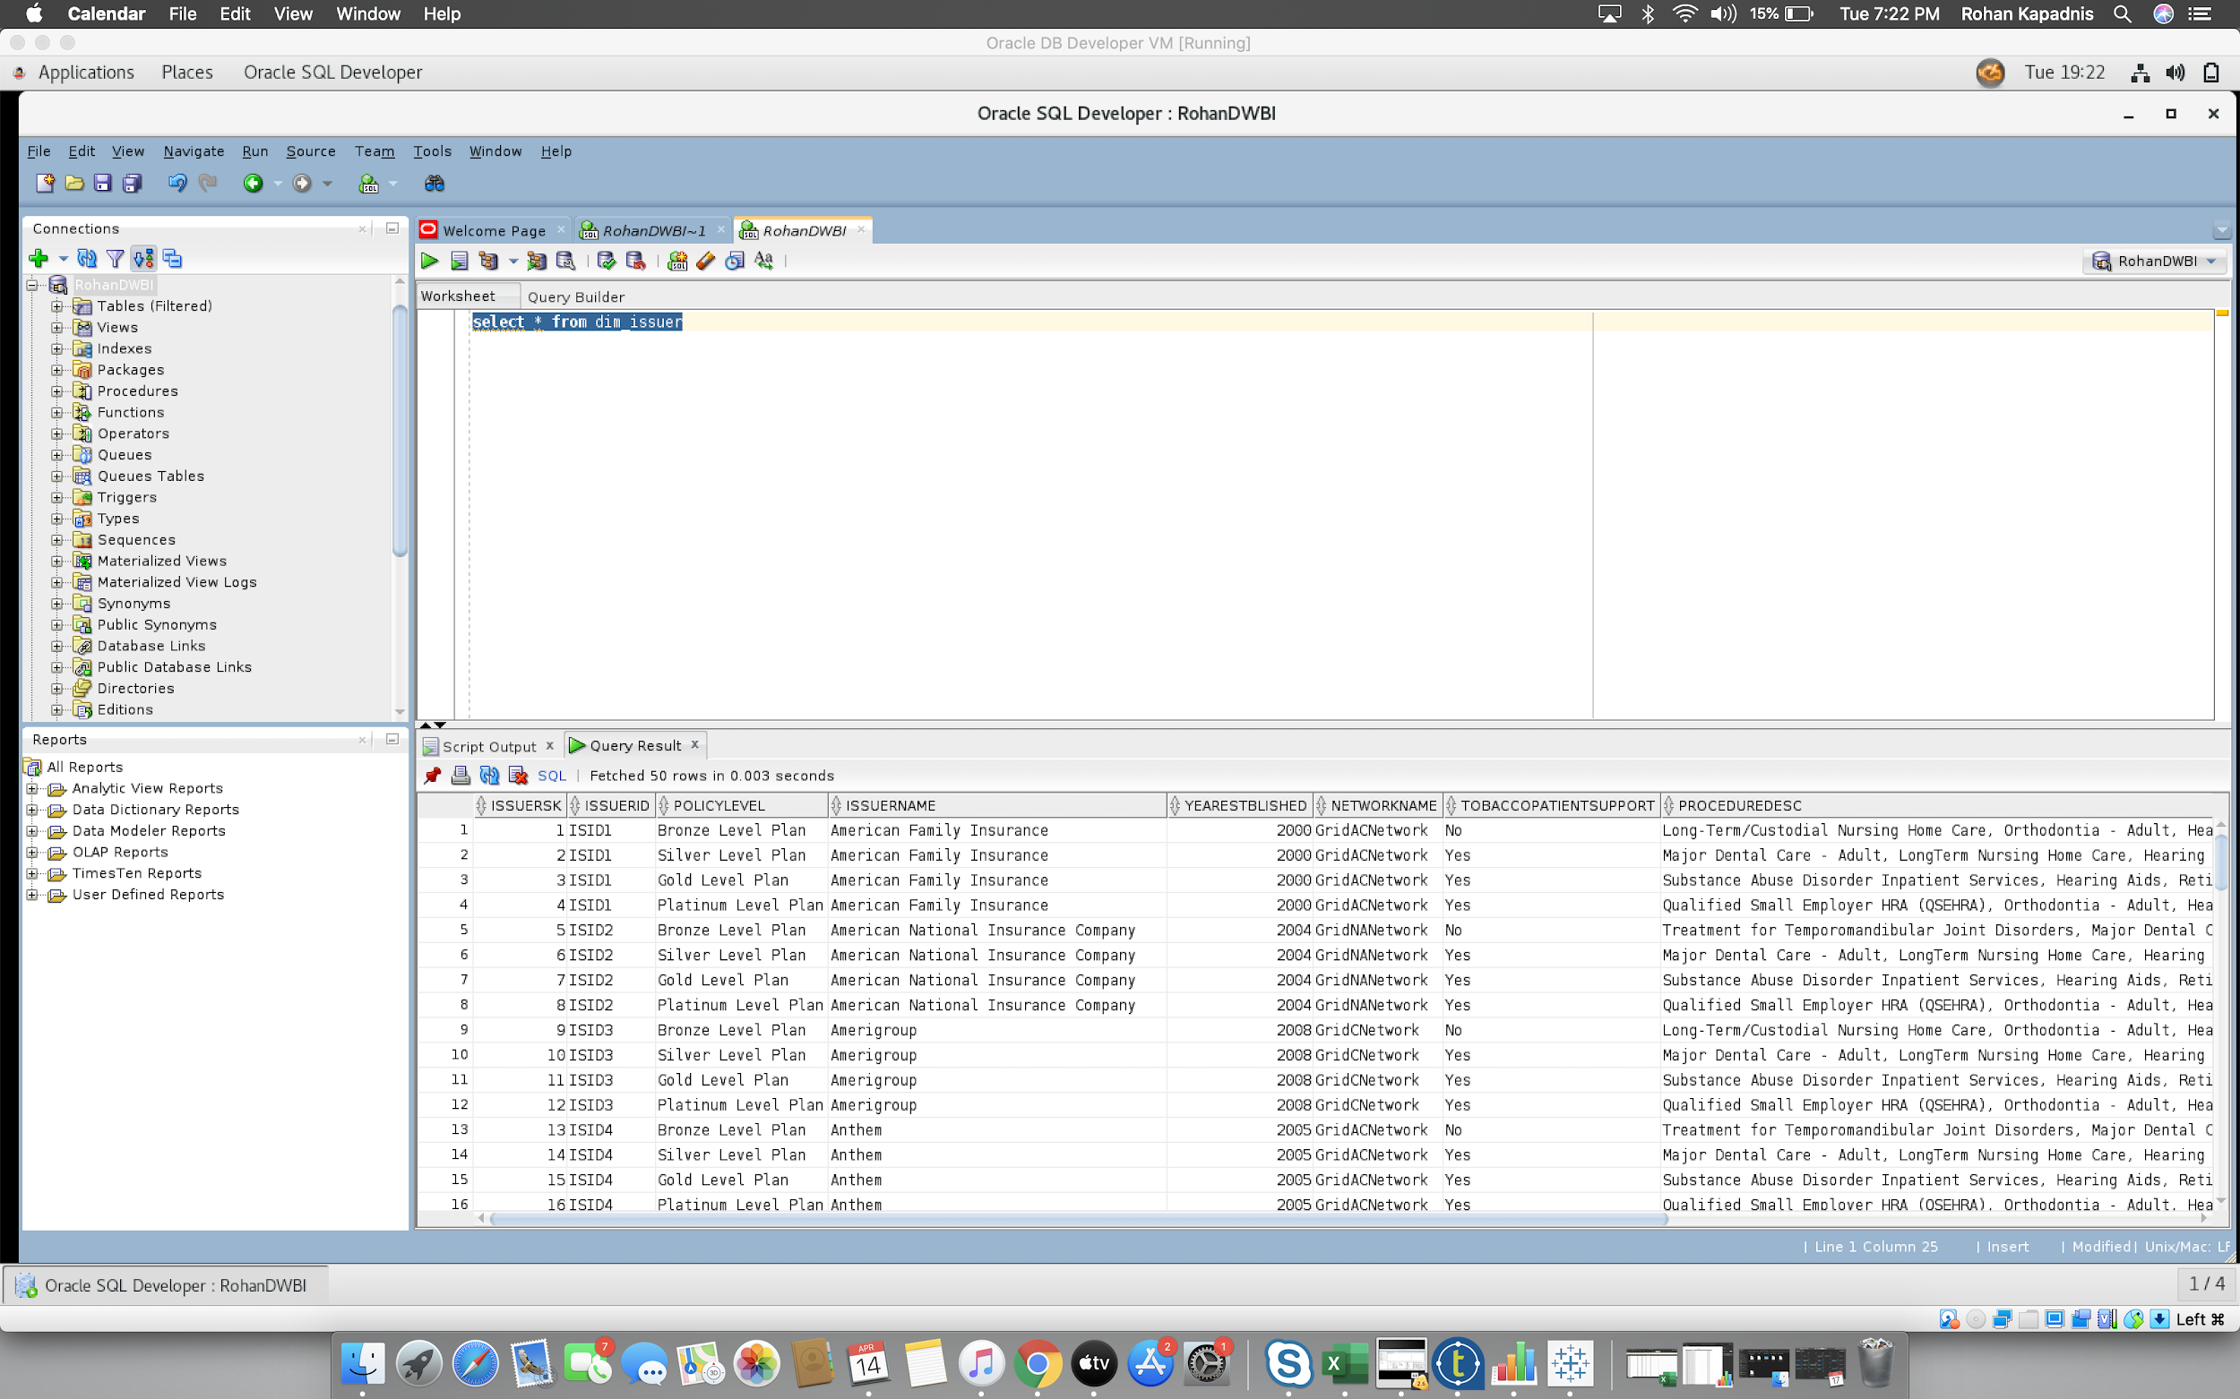

* **c. Dimension Policy**

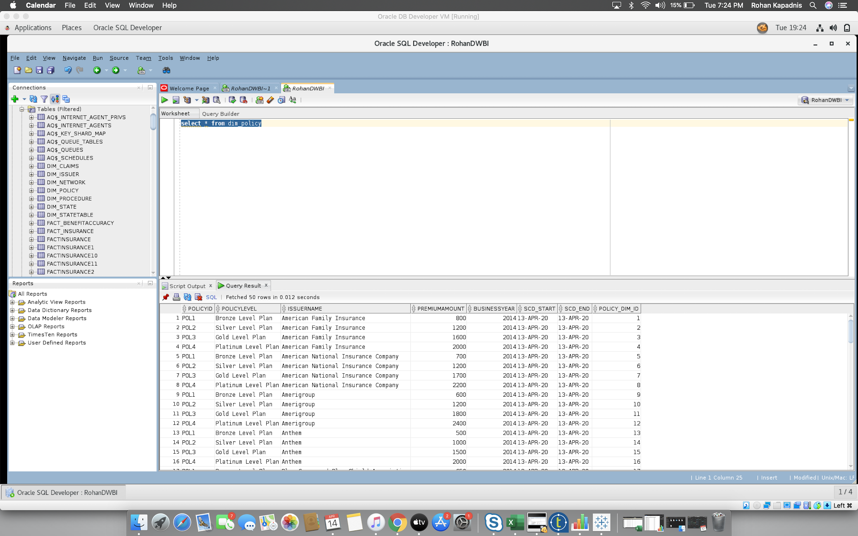

* **d. Dimension State**

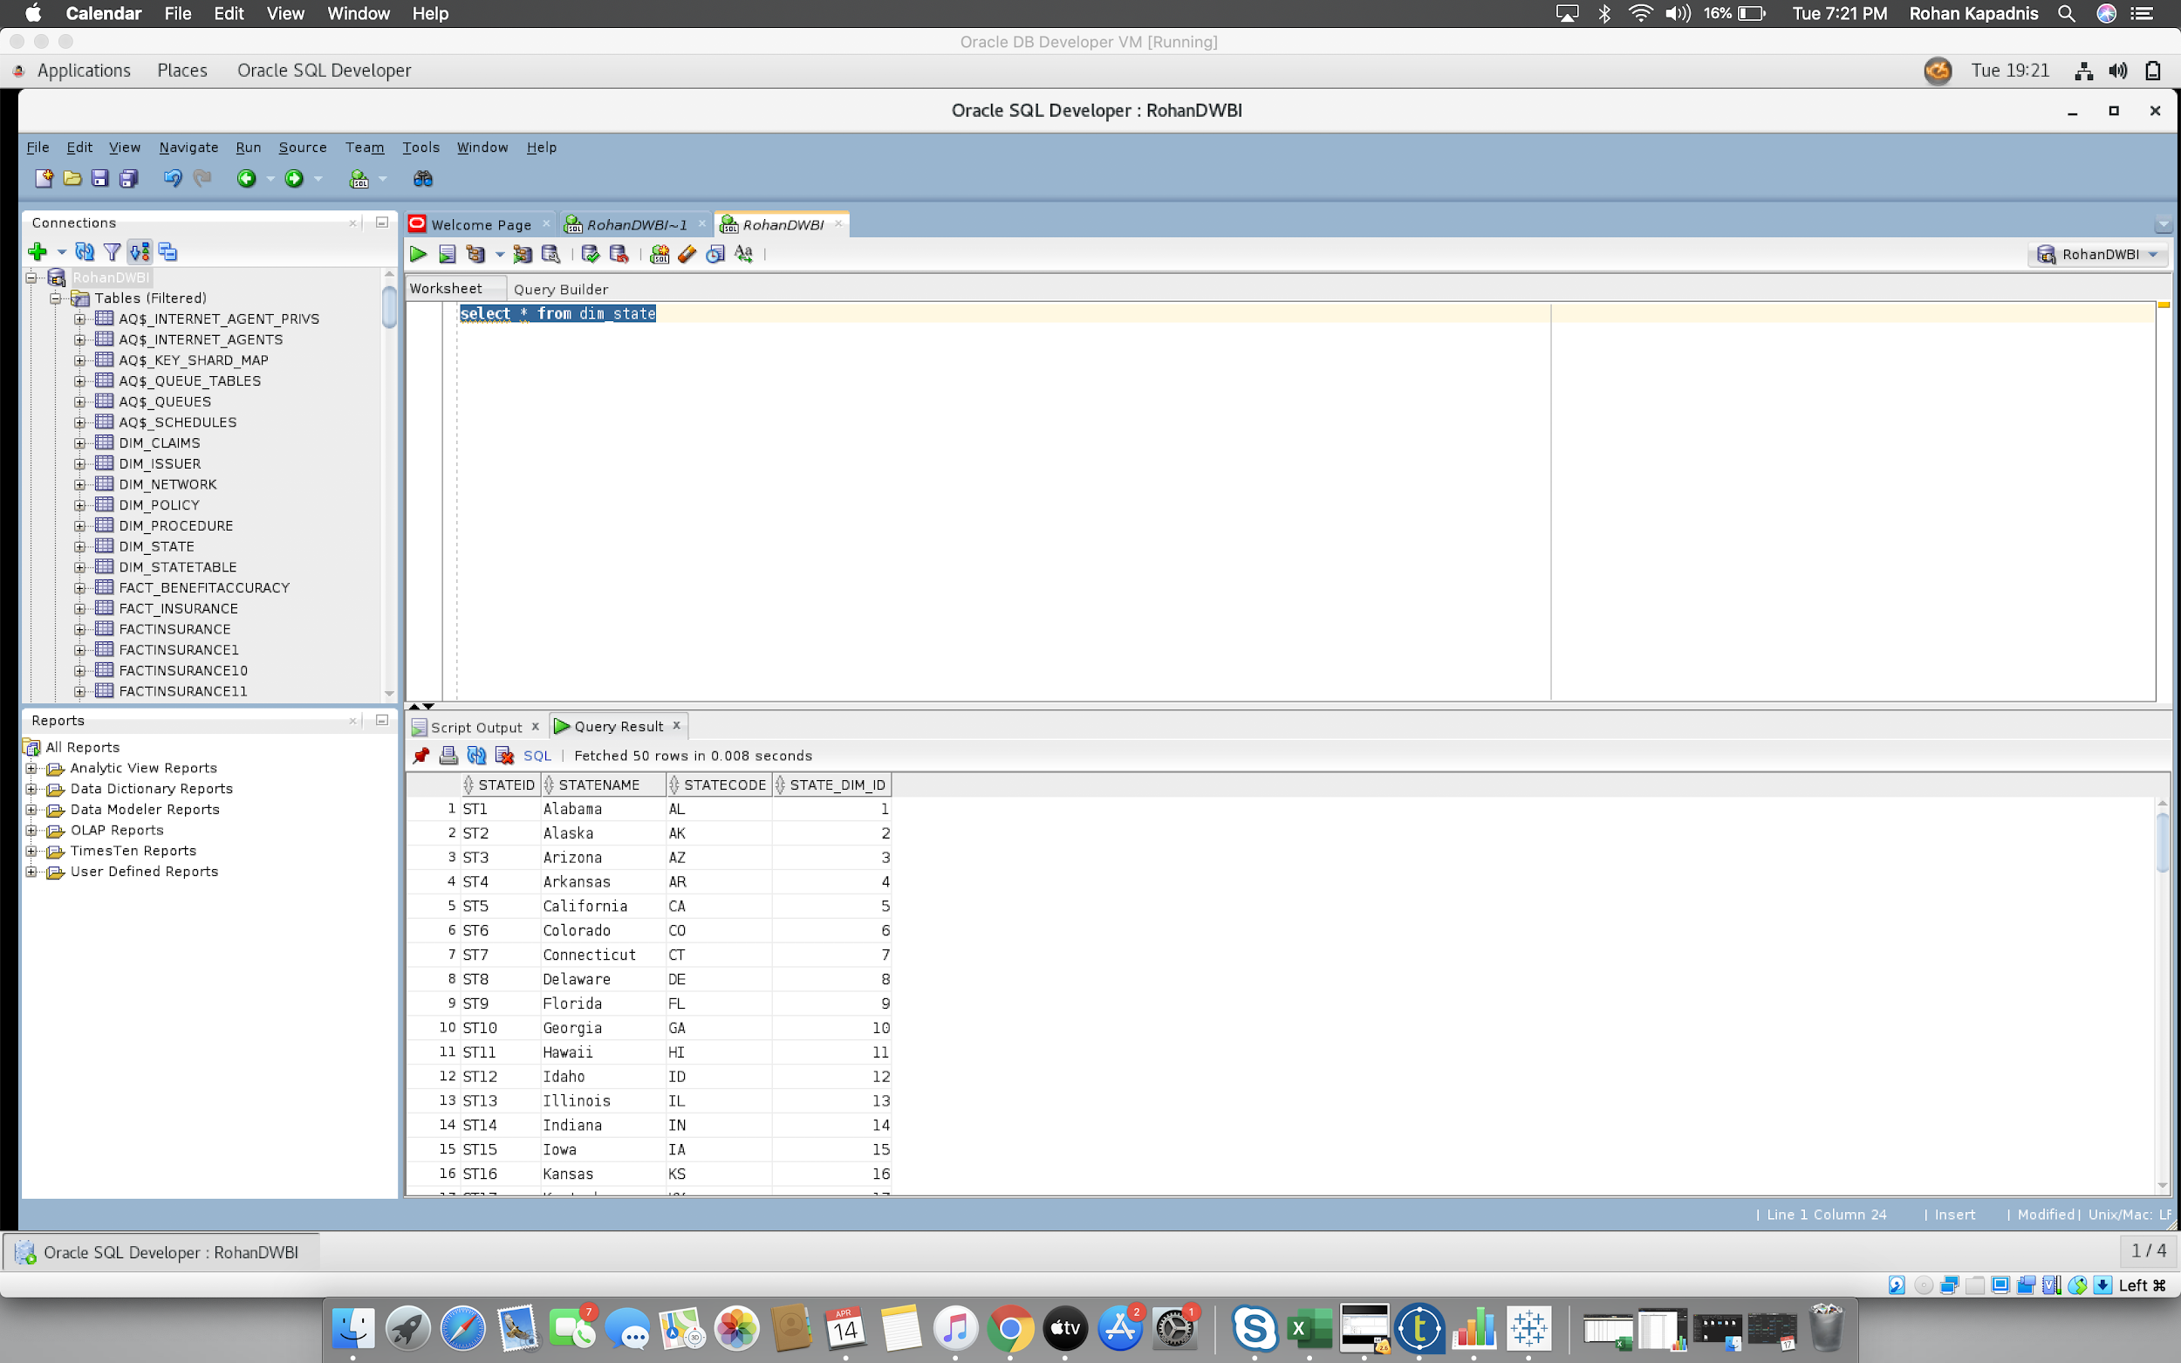

* **e. Dimension Procedure**

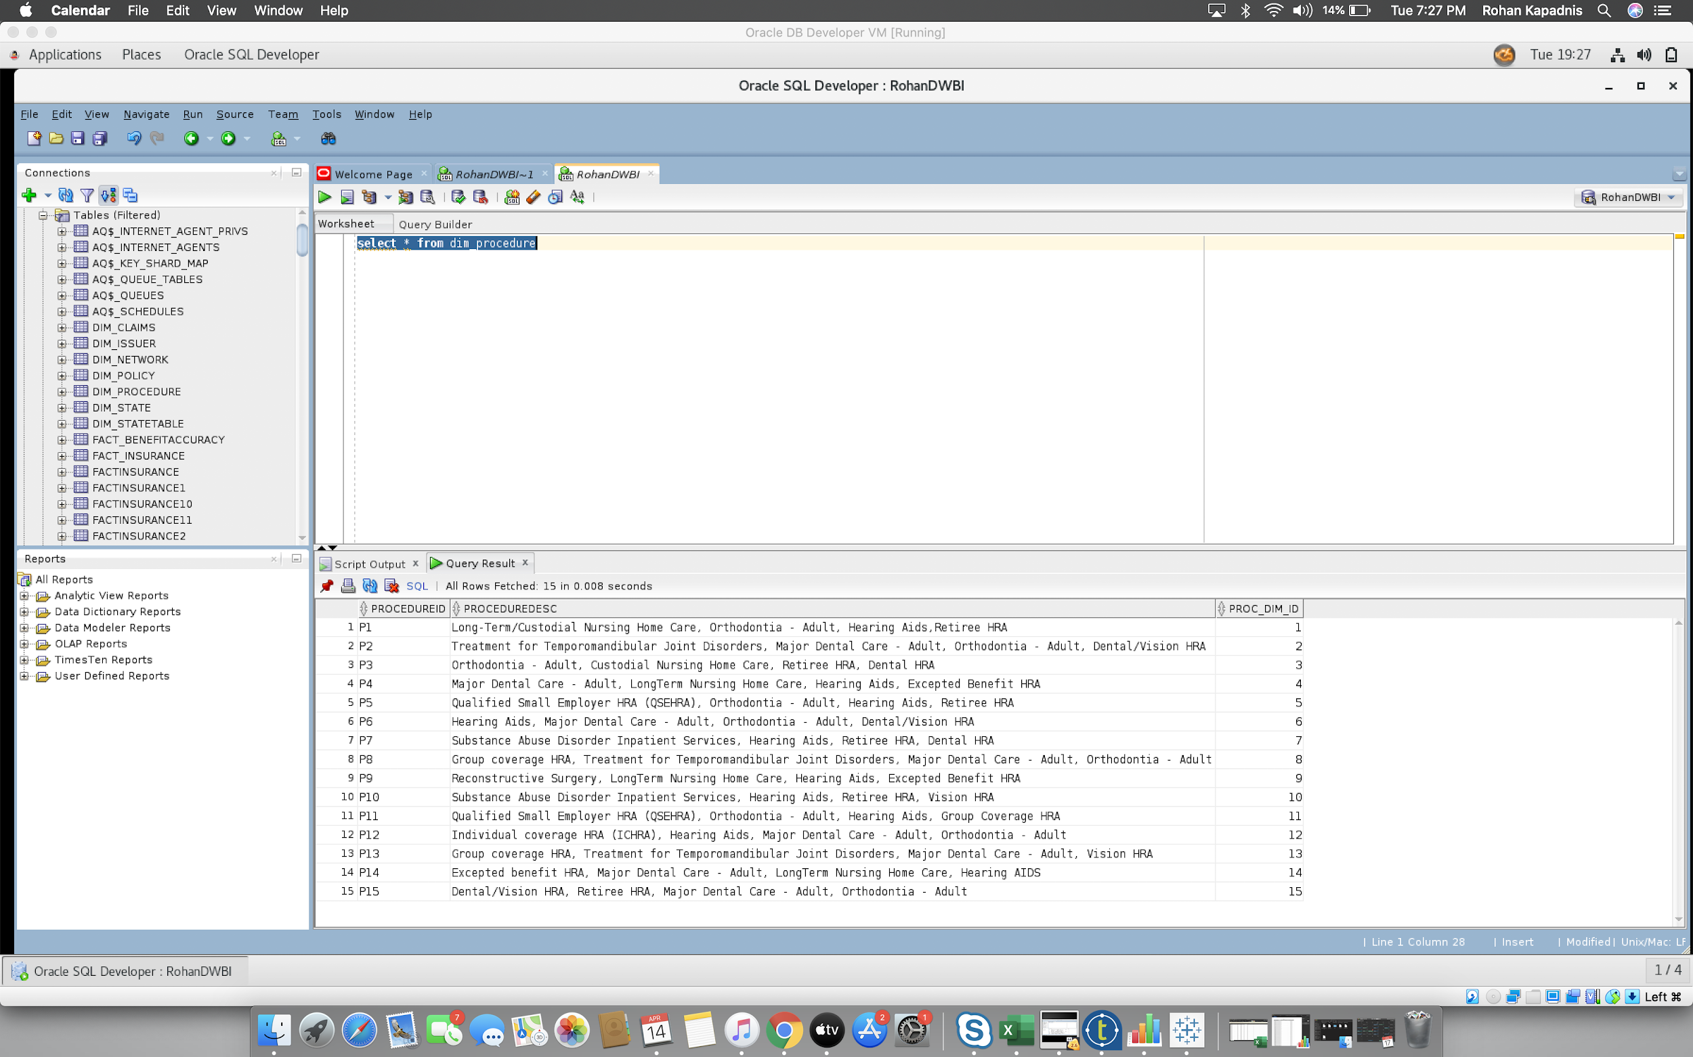

* **f. Dimension Network**

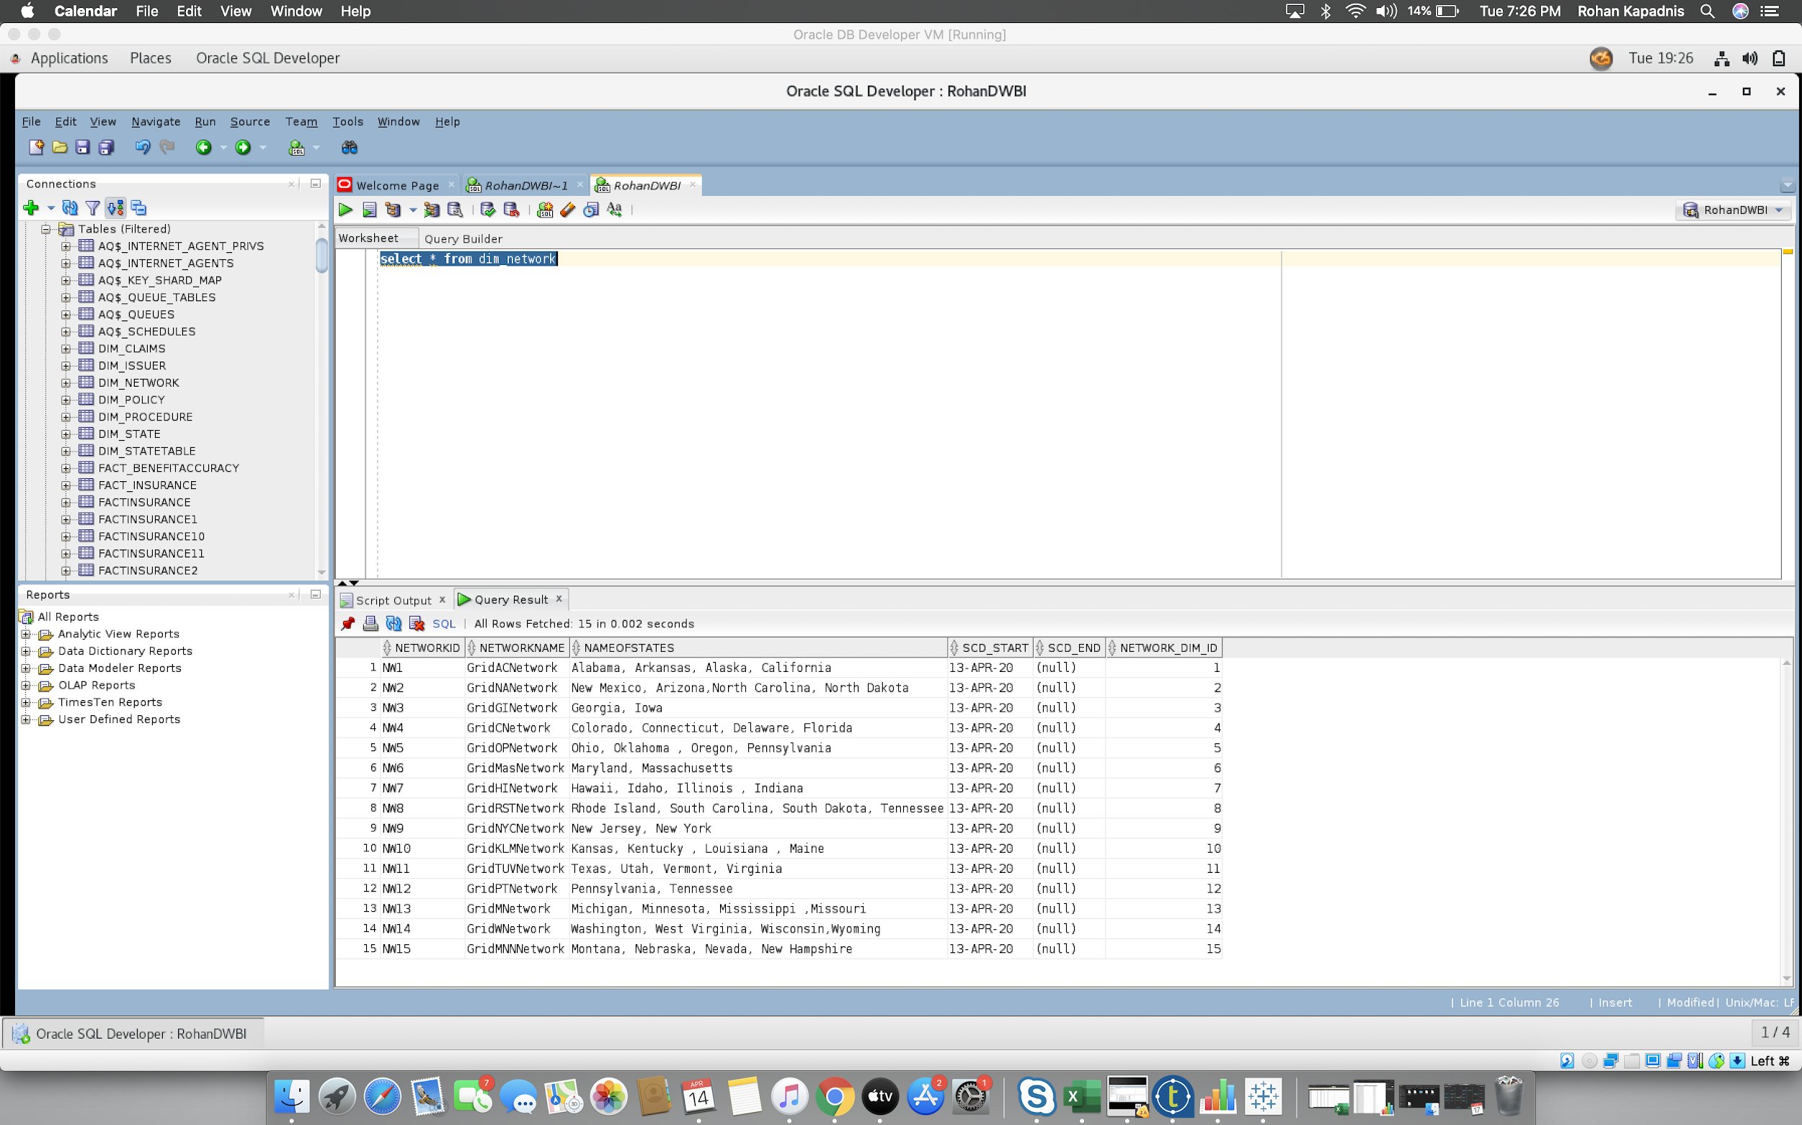

* **g. Fact Insurance**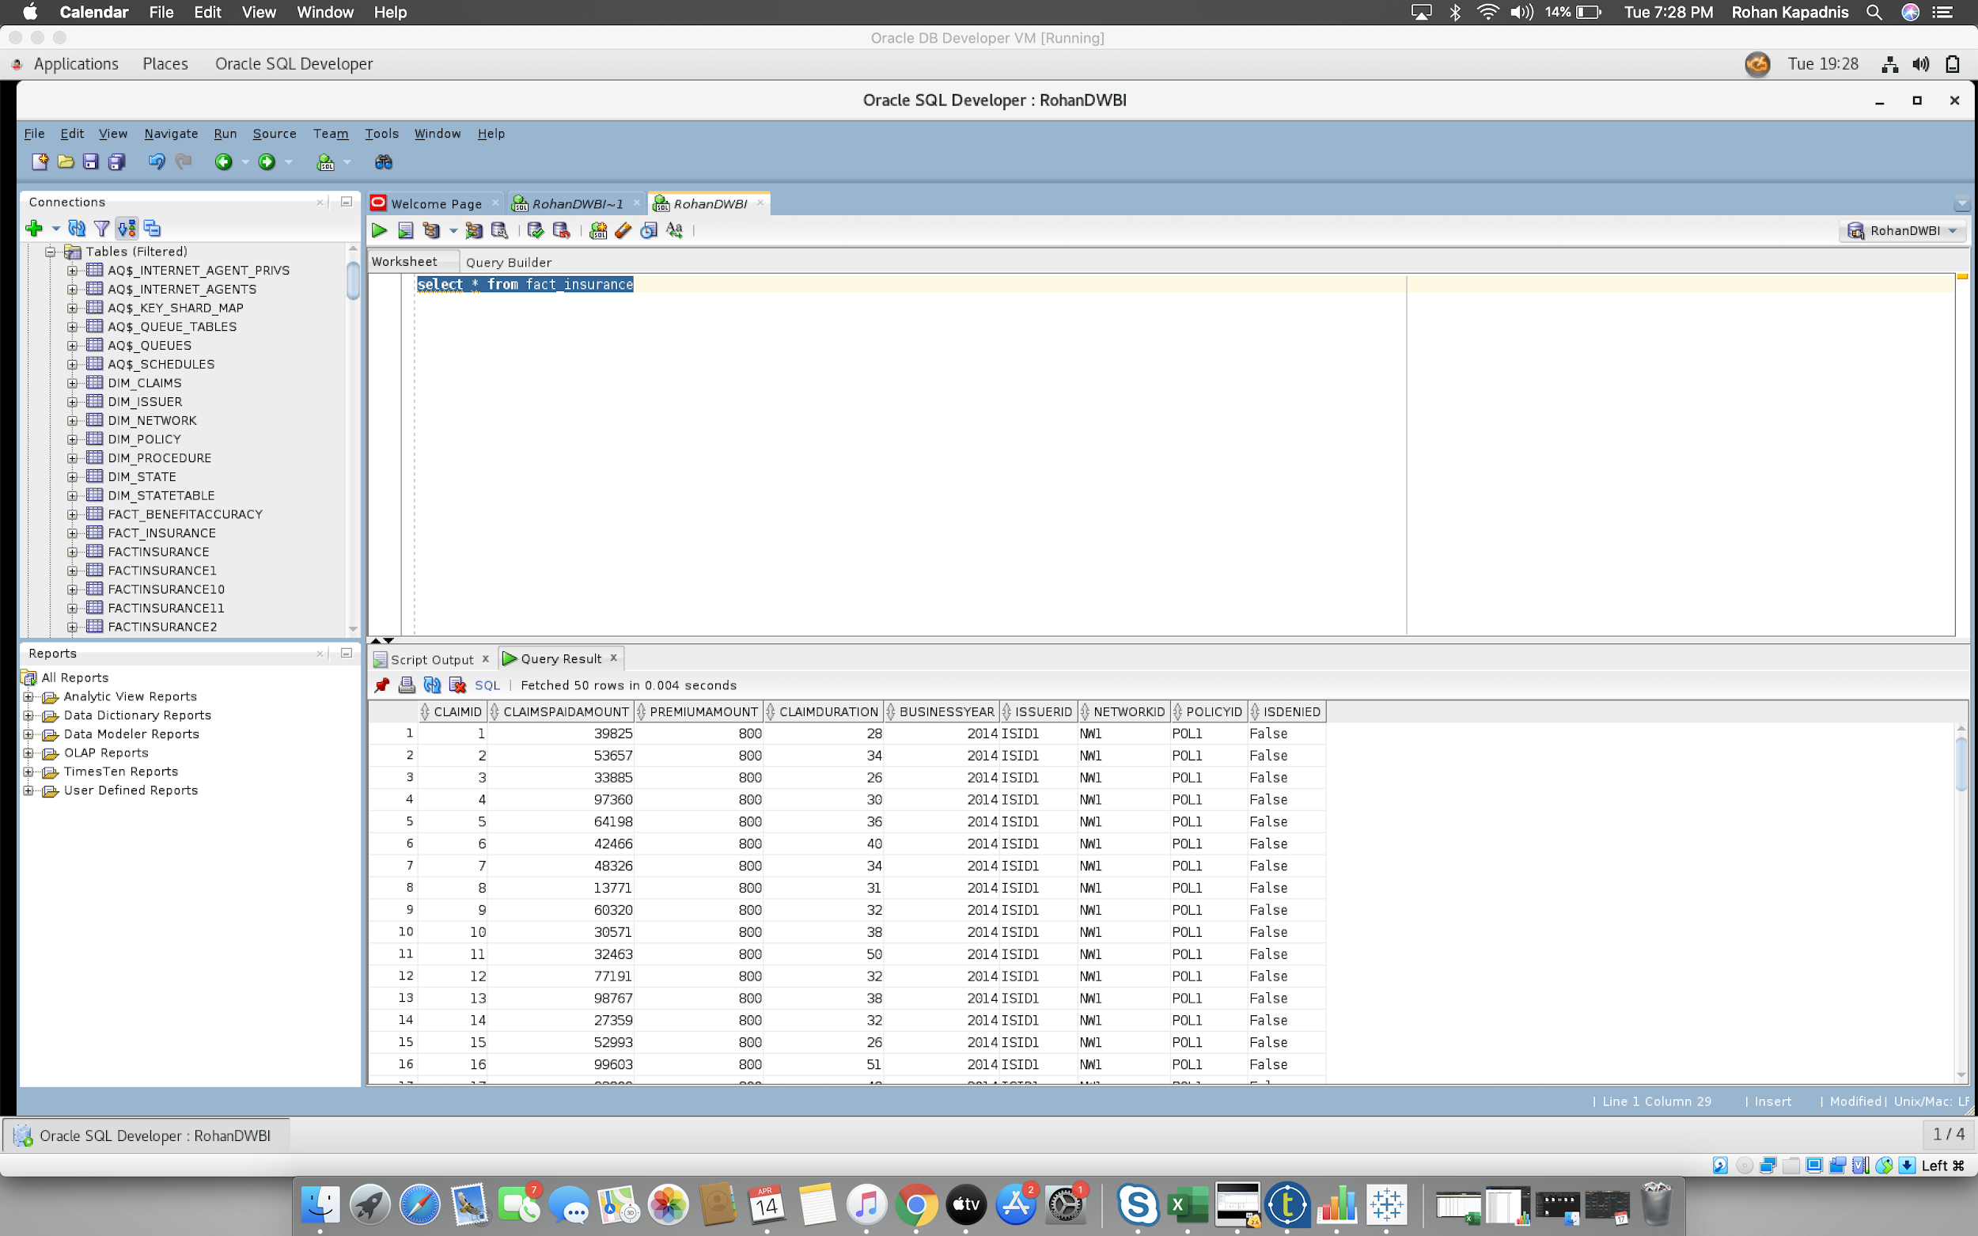
* **h. Fact BenefitAccuracy**

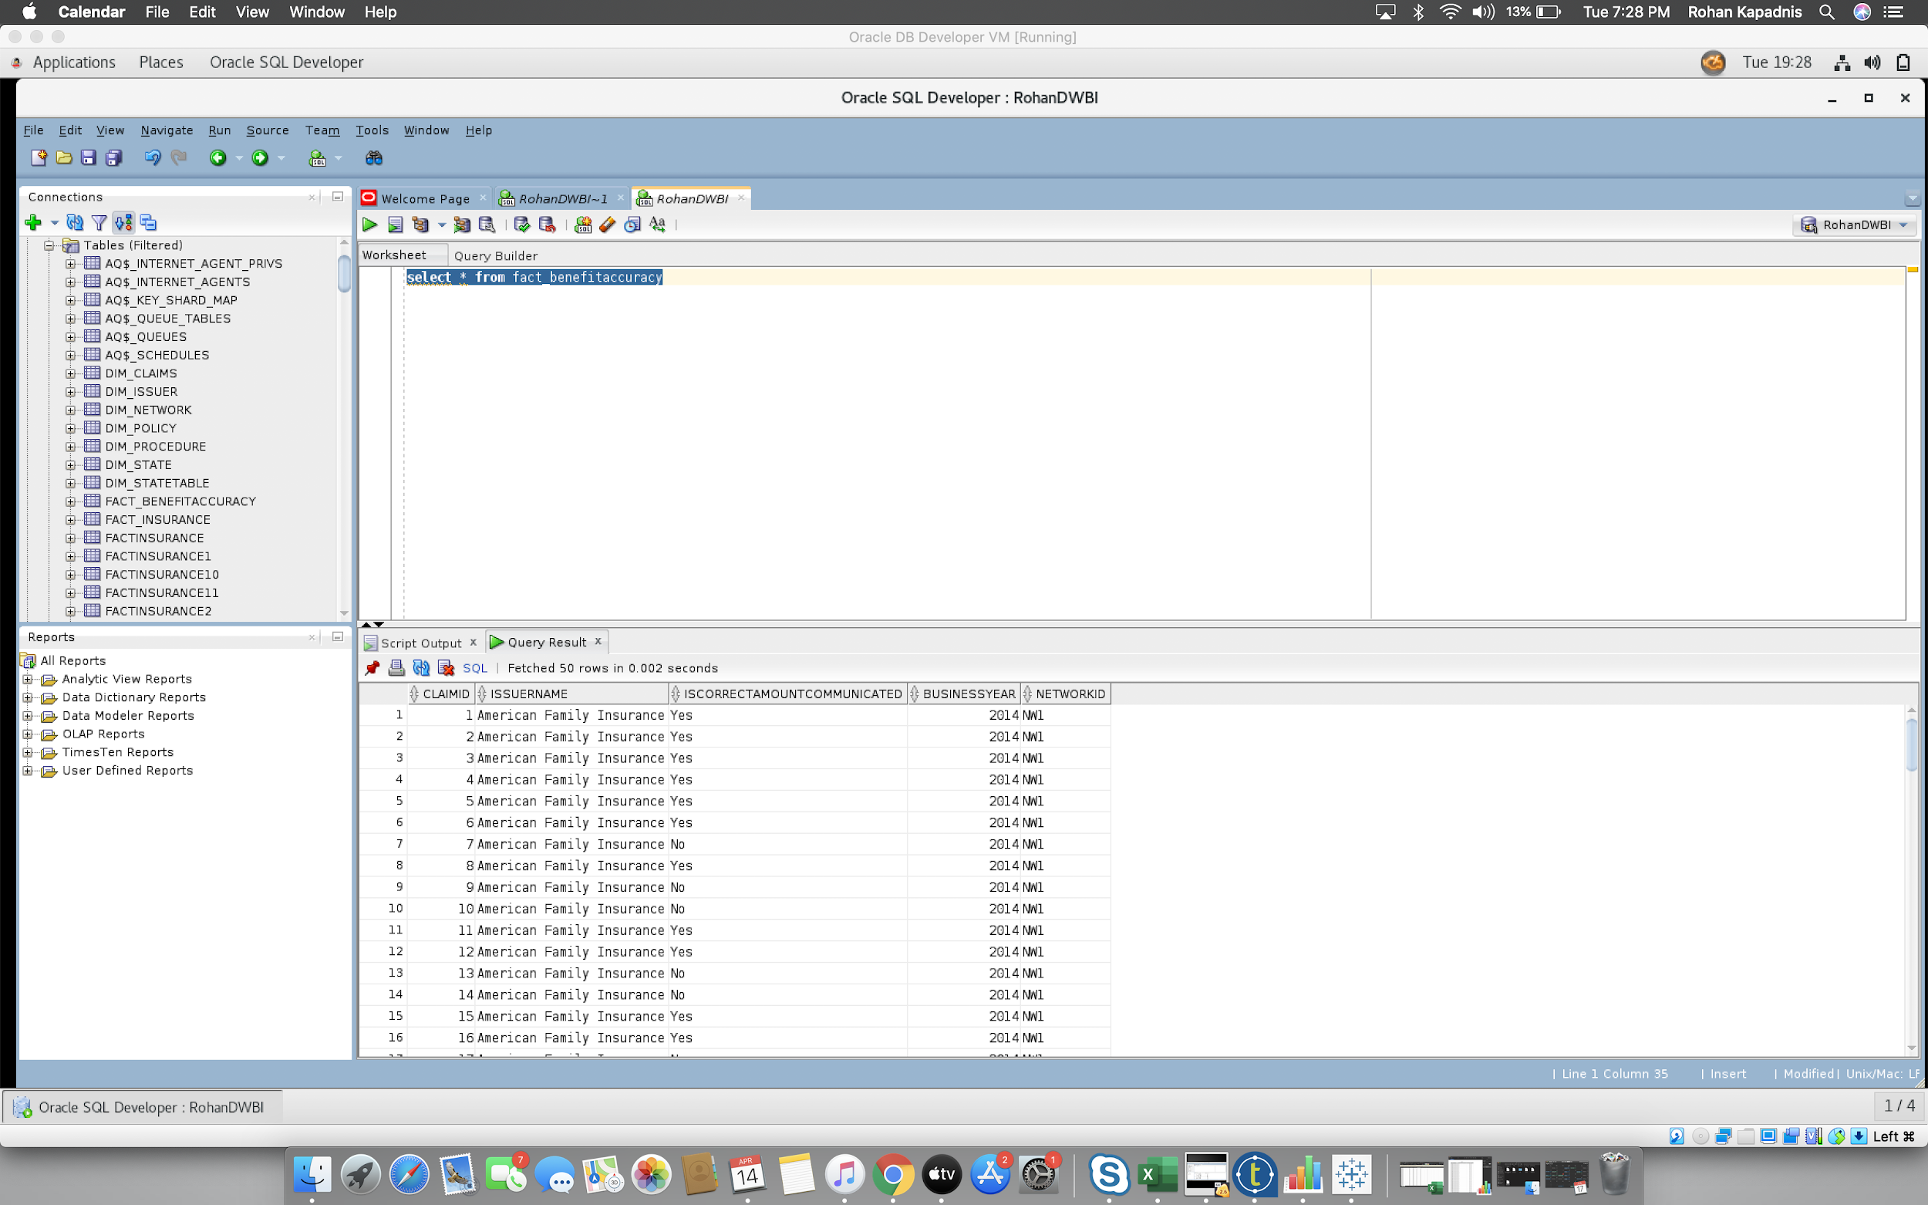

1. **Tableau**

* **A. Claim Settlement Cycle SHEETS**

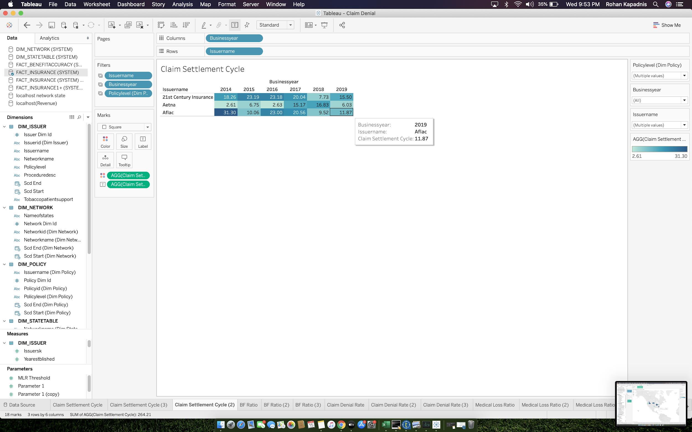

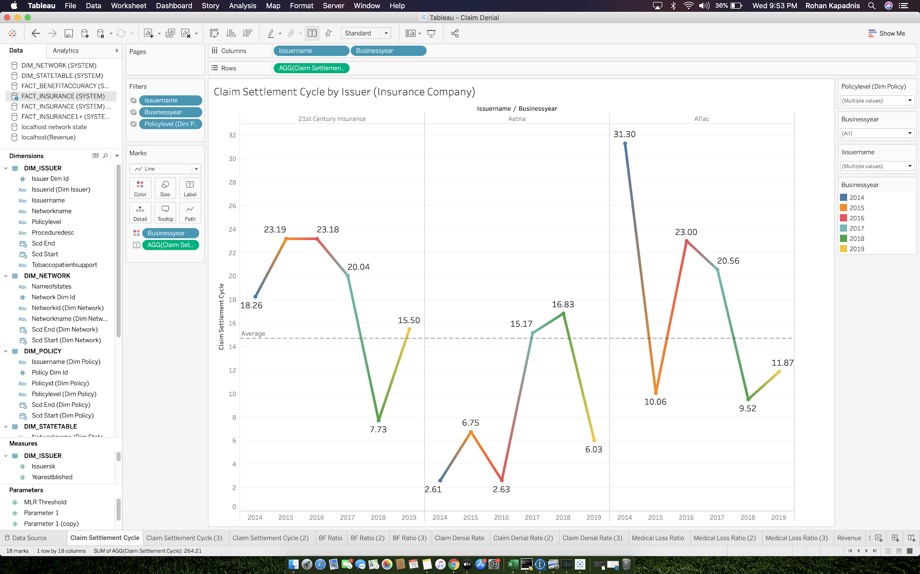

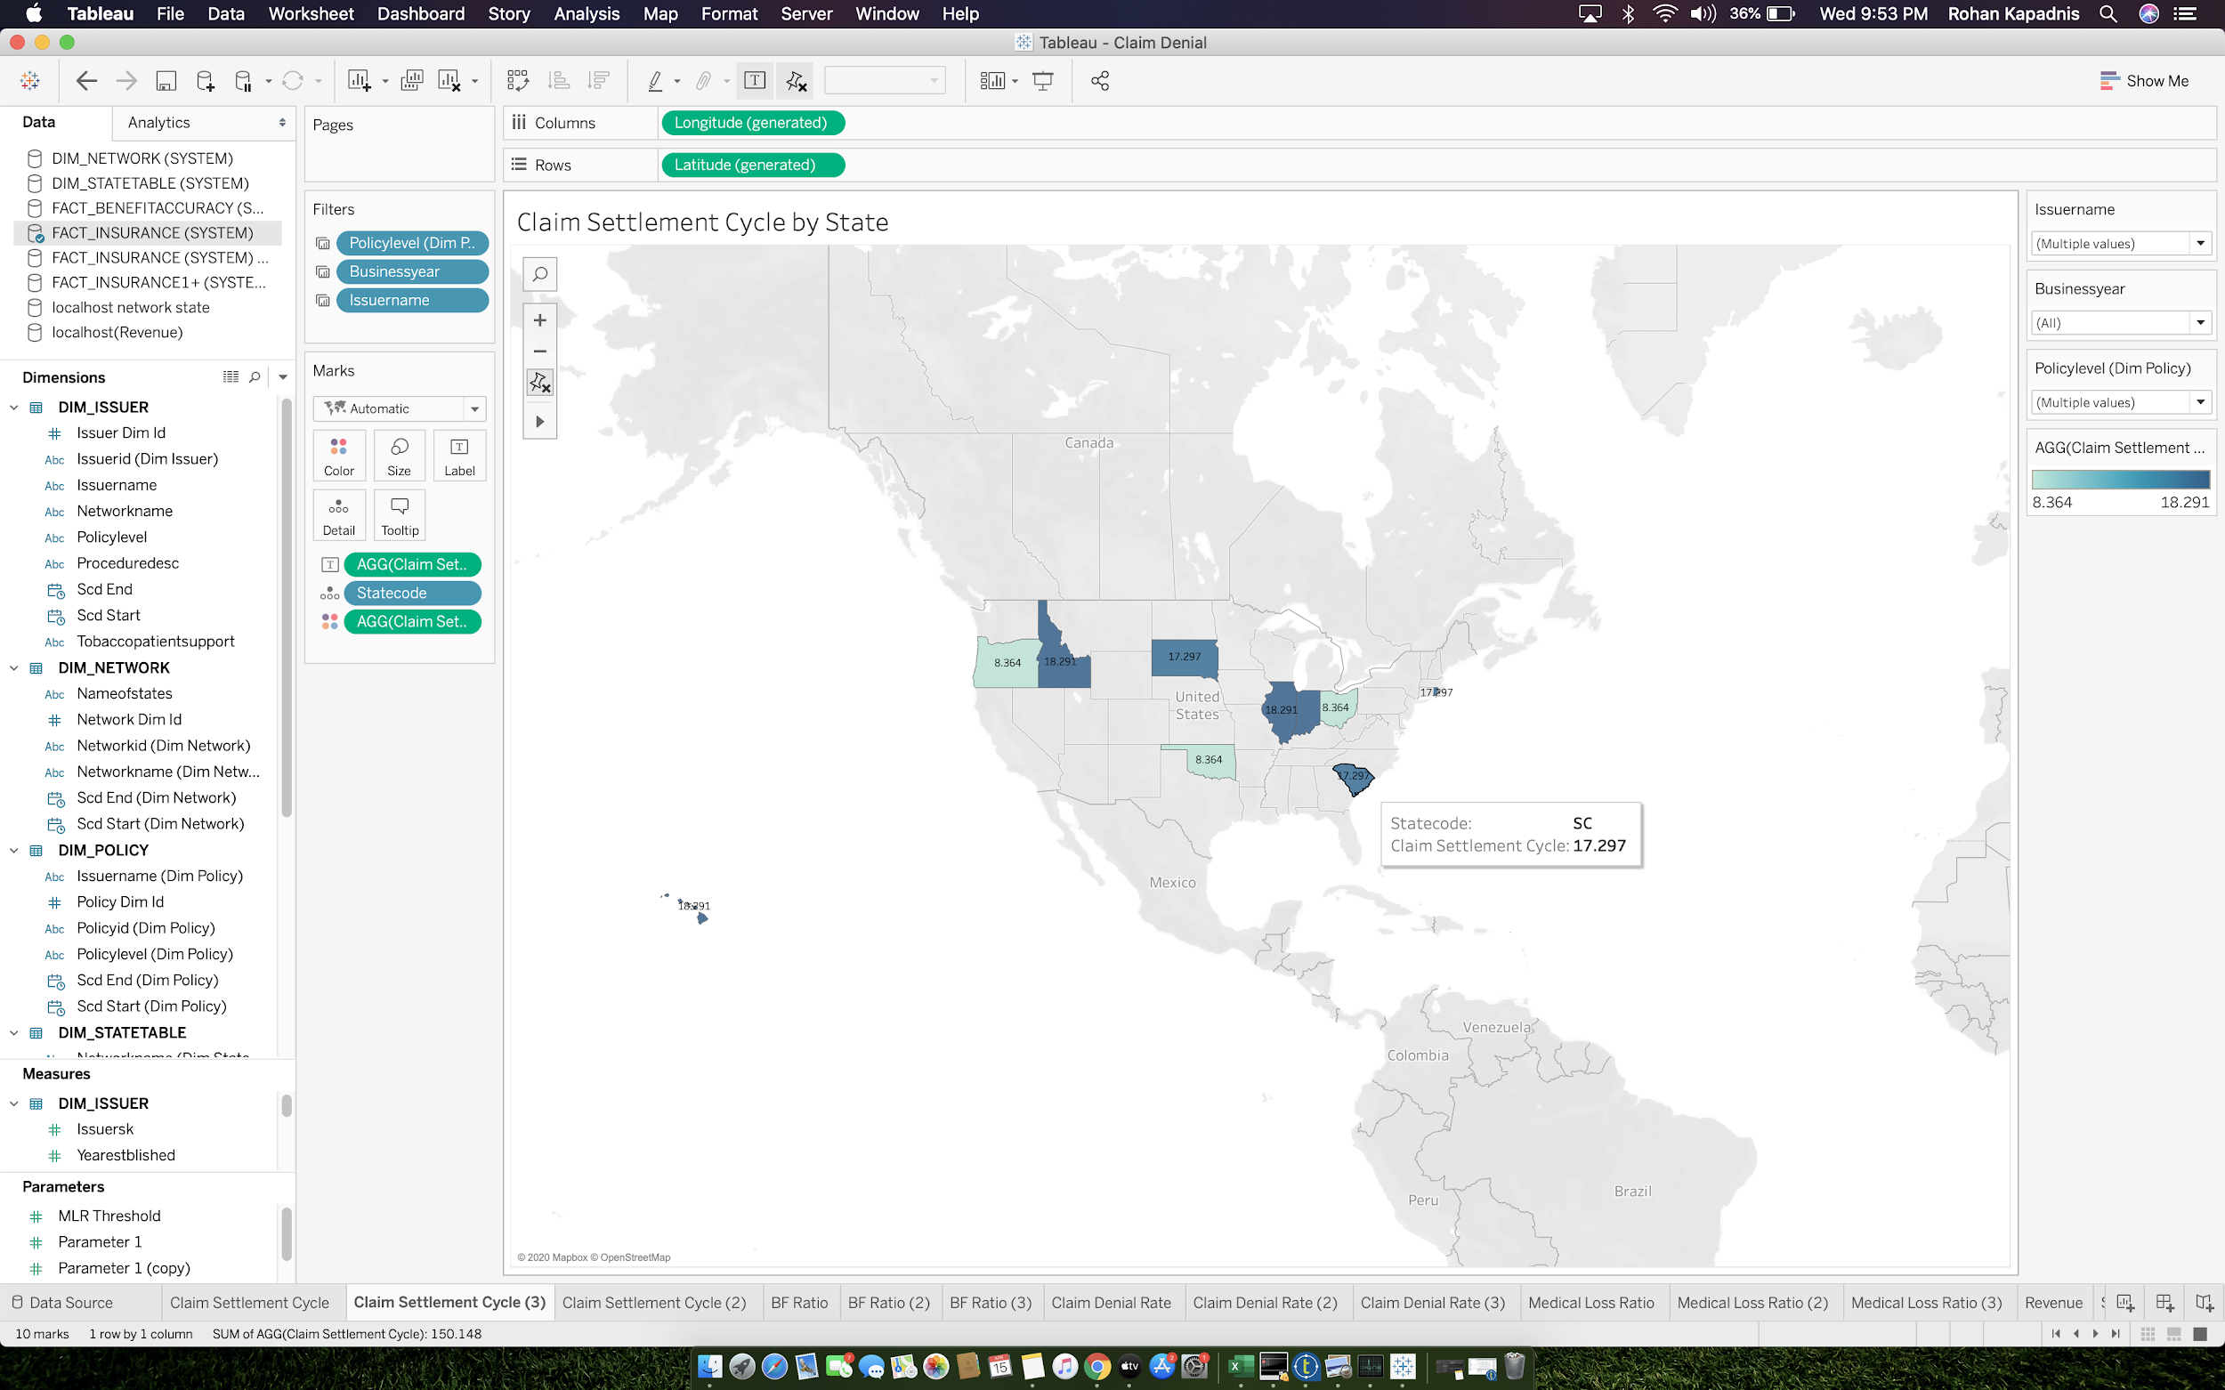

* **B.Benefit Accuracy Rate SHEETS**

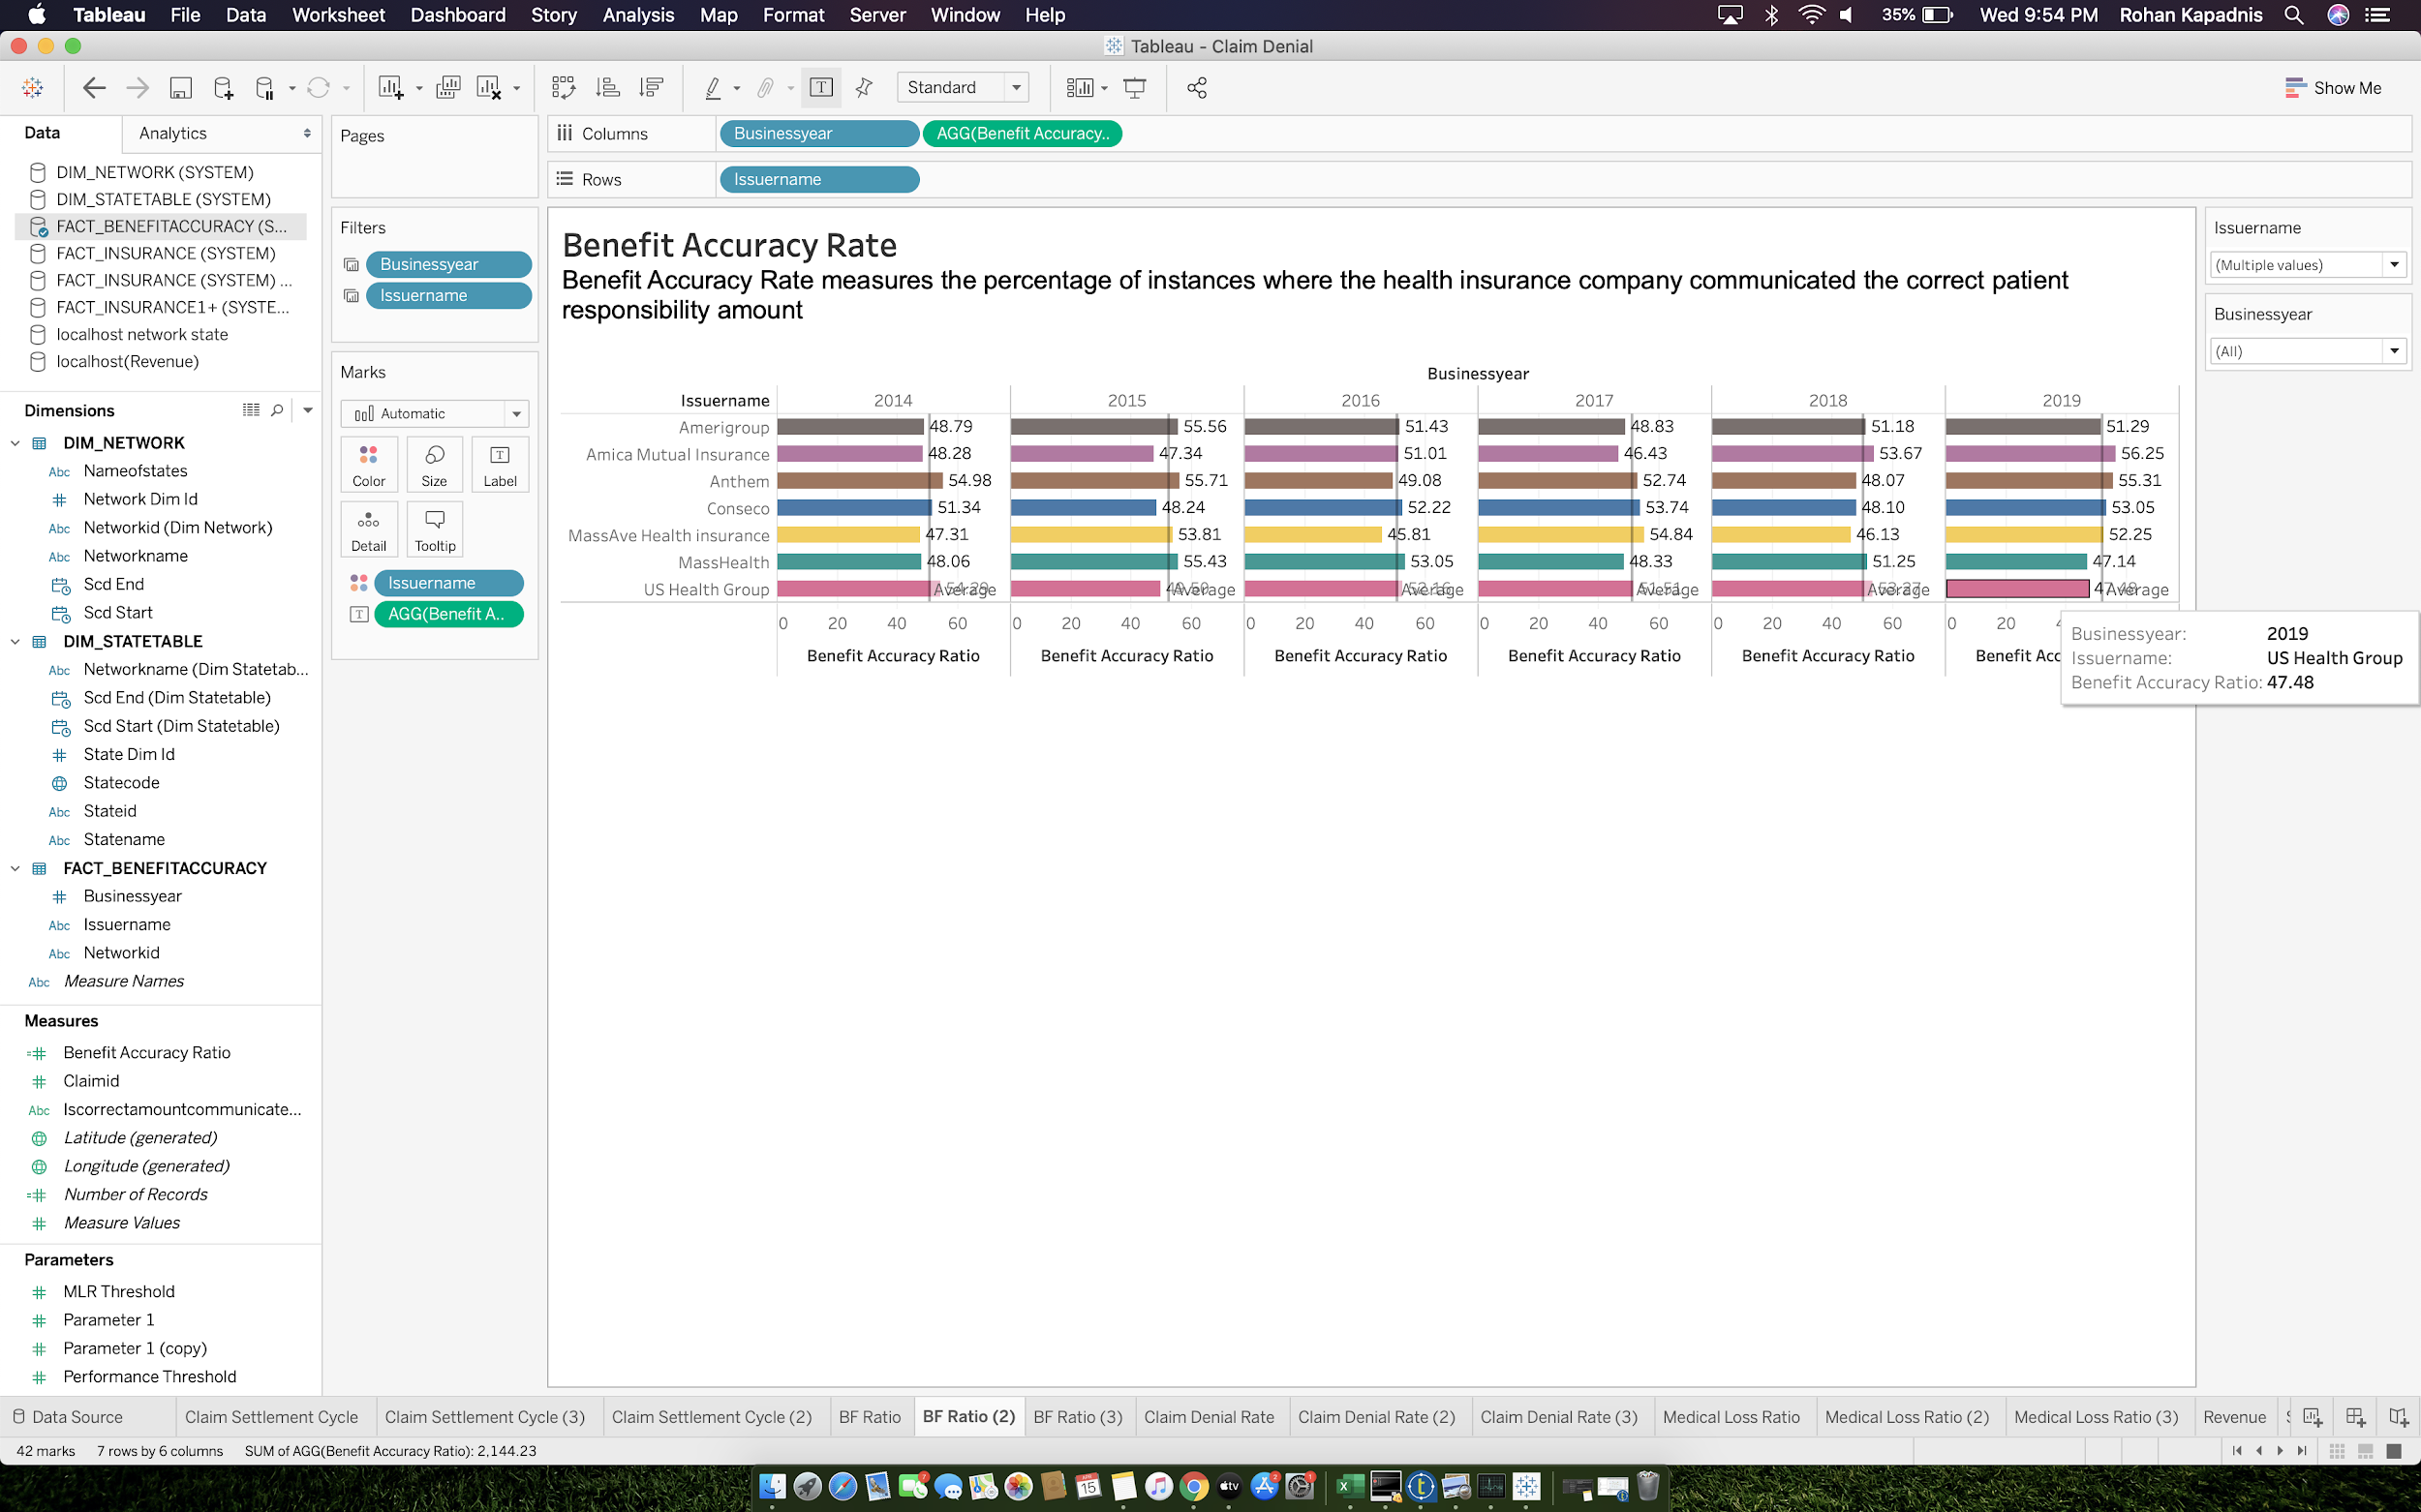

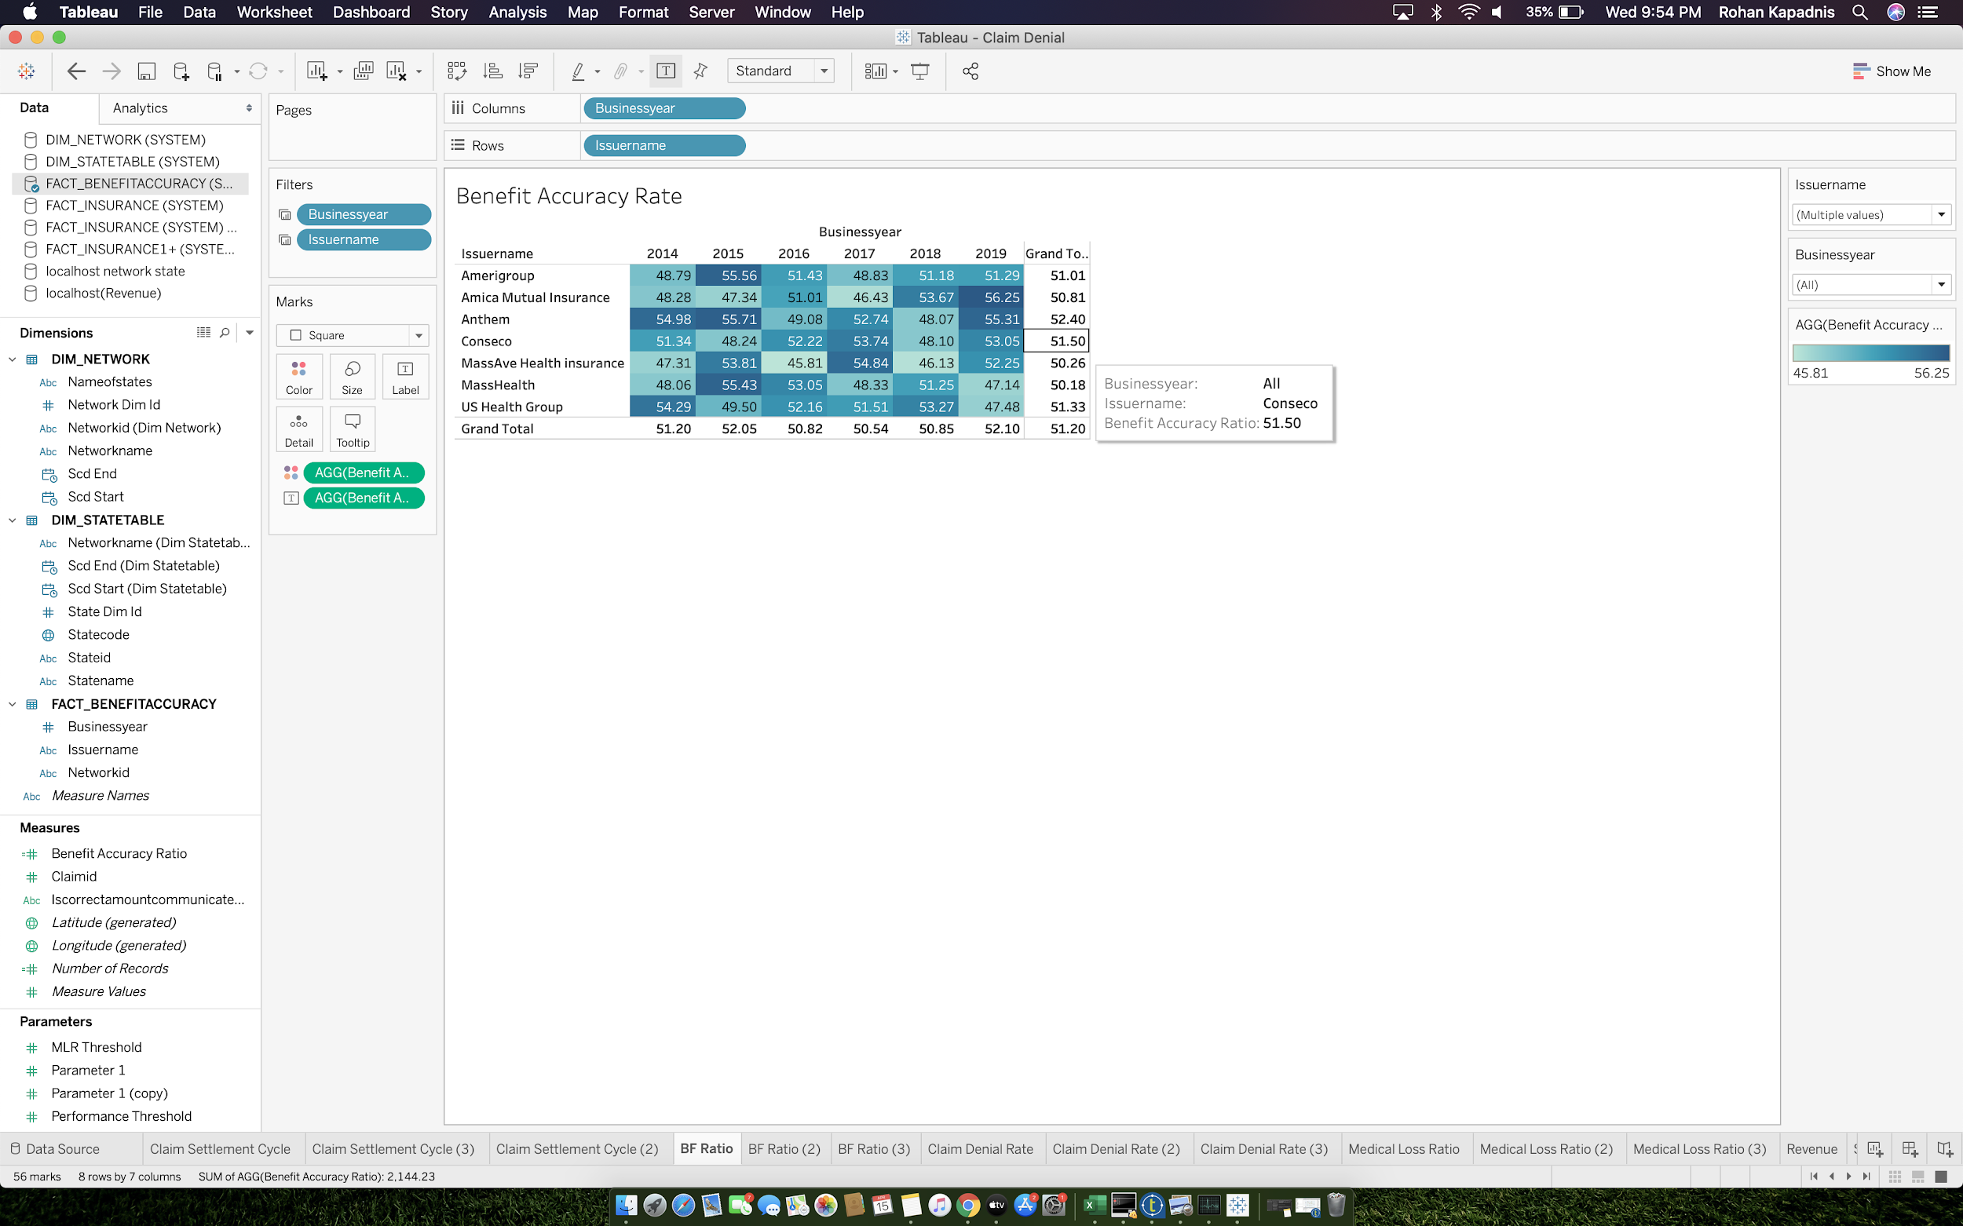

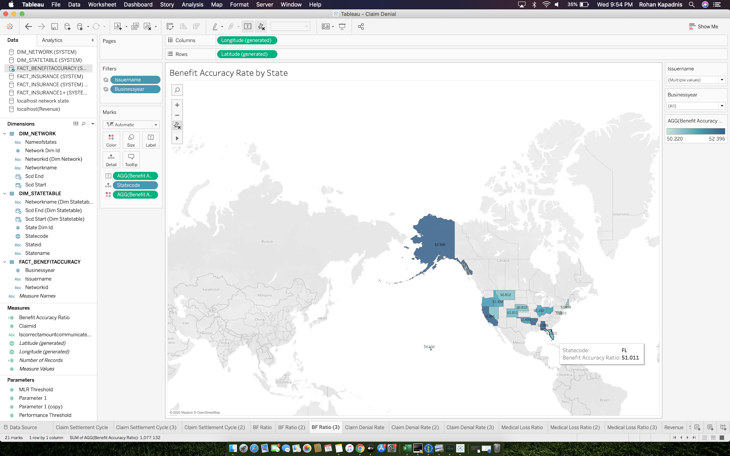

* **C. Claim Denial Rate SHEETS**

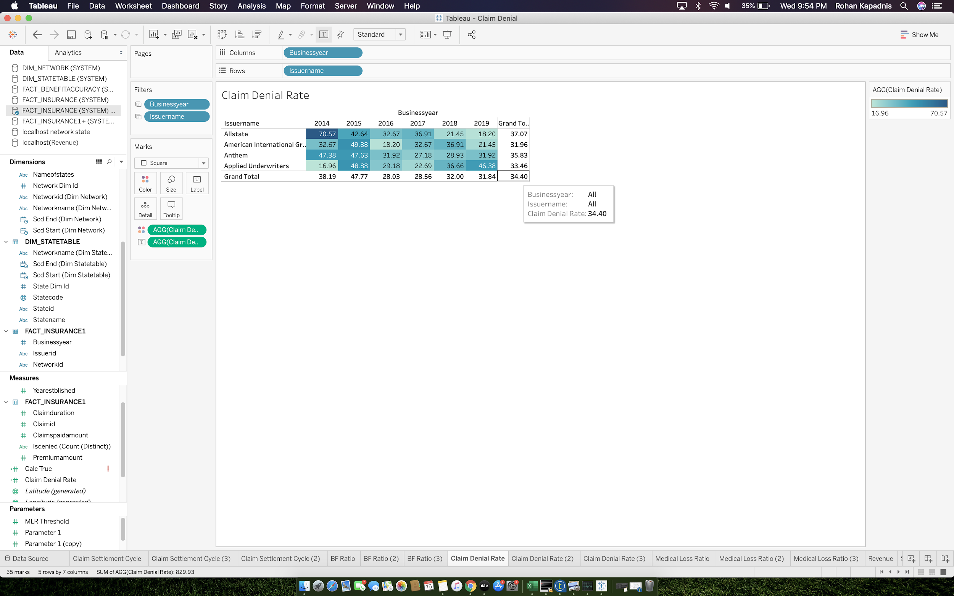

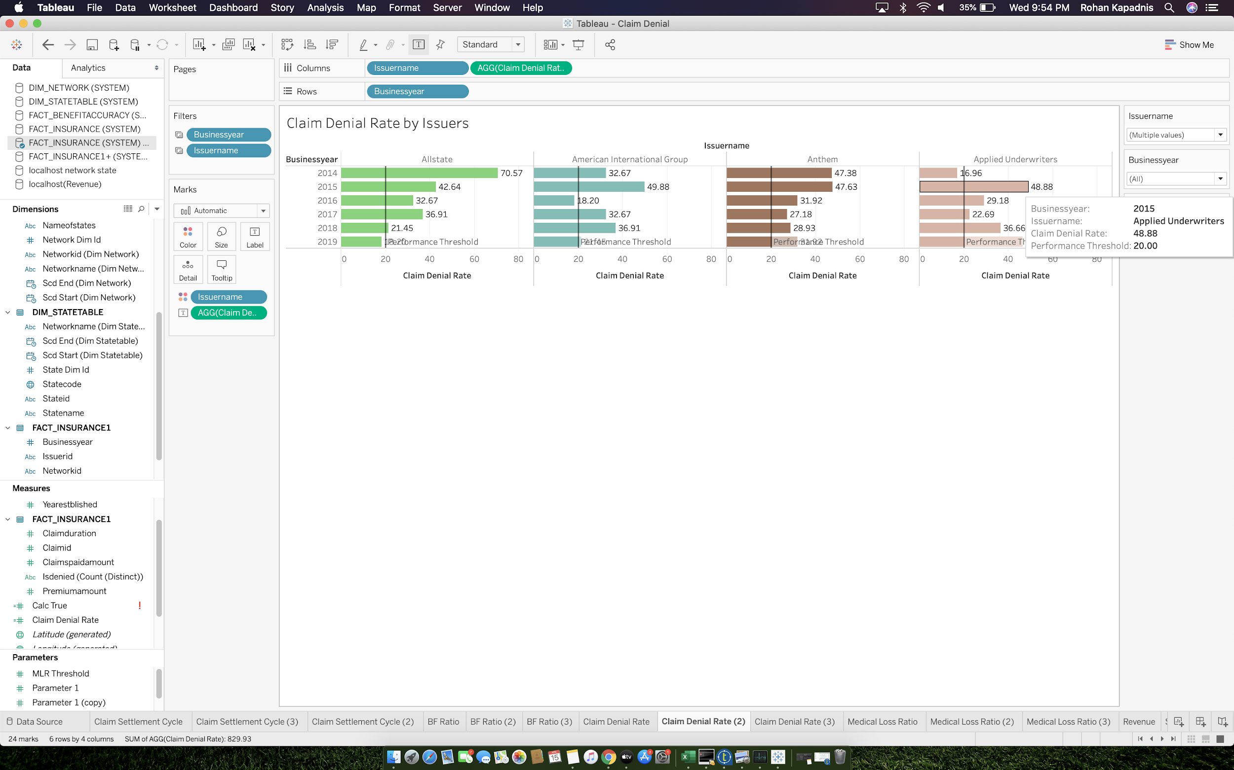

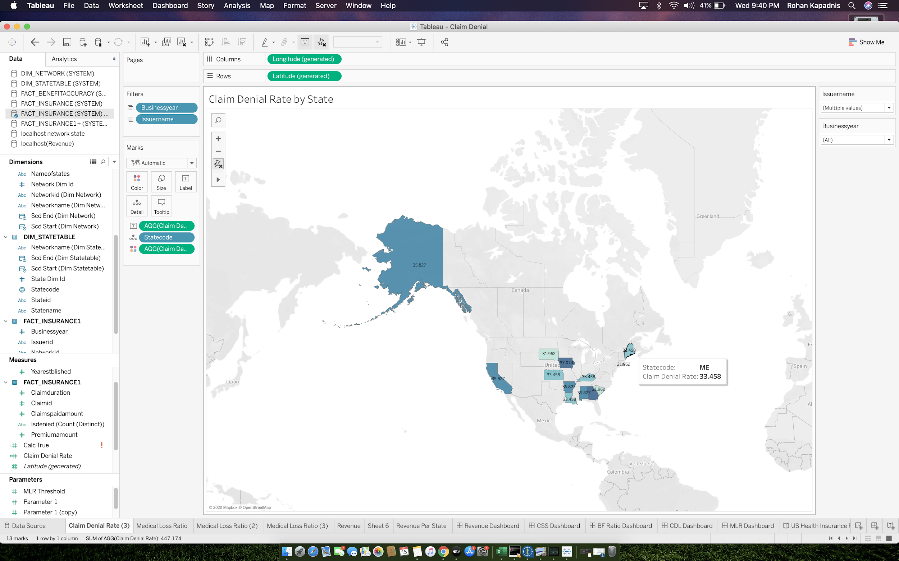

* **D. Medical Loss Ratio SHEETS**

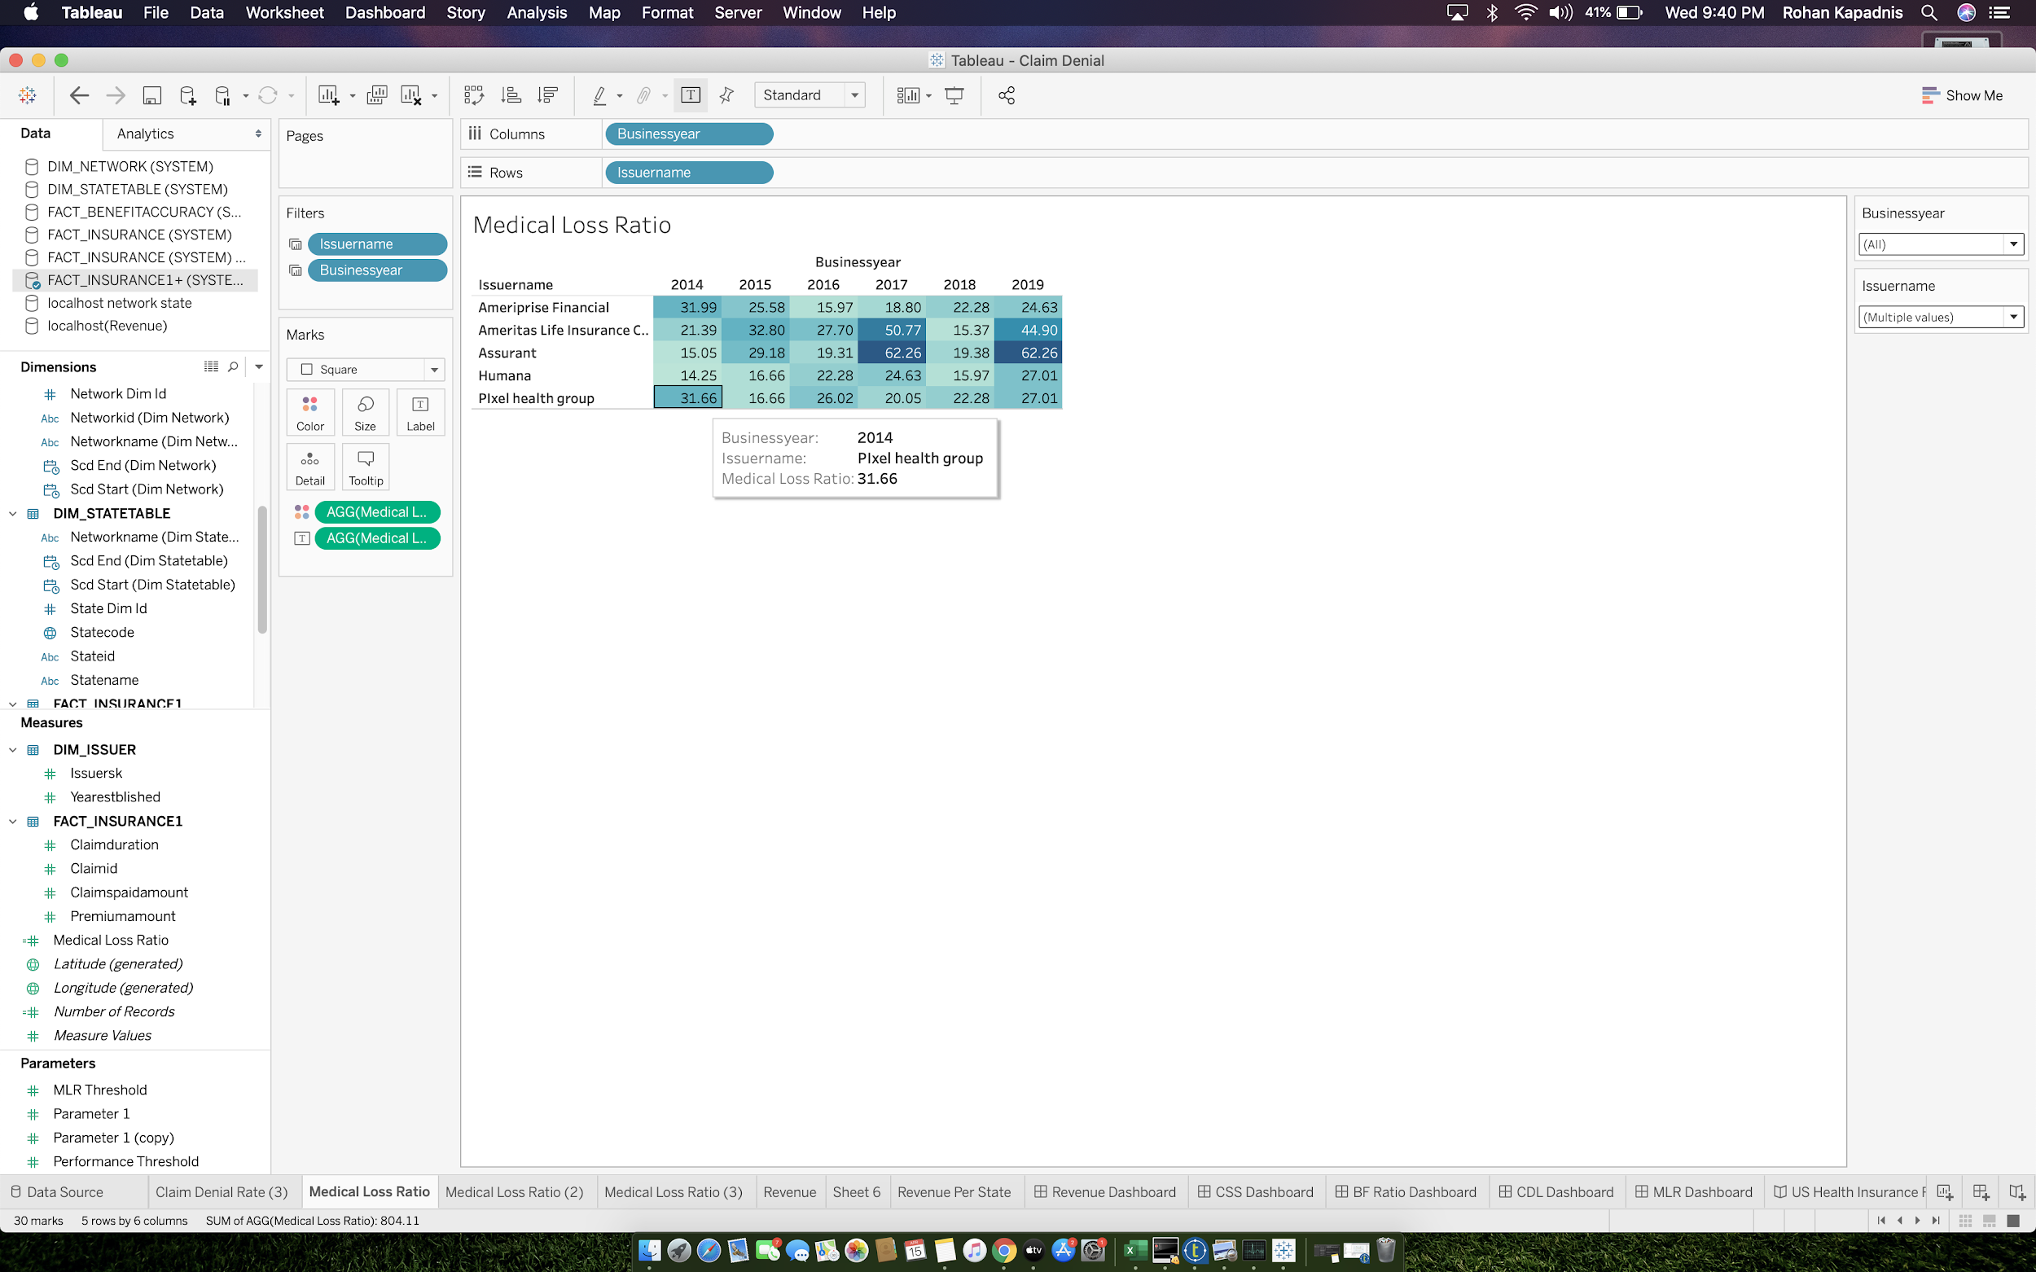

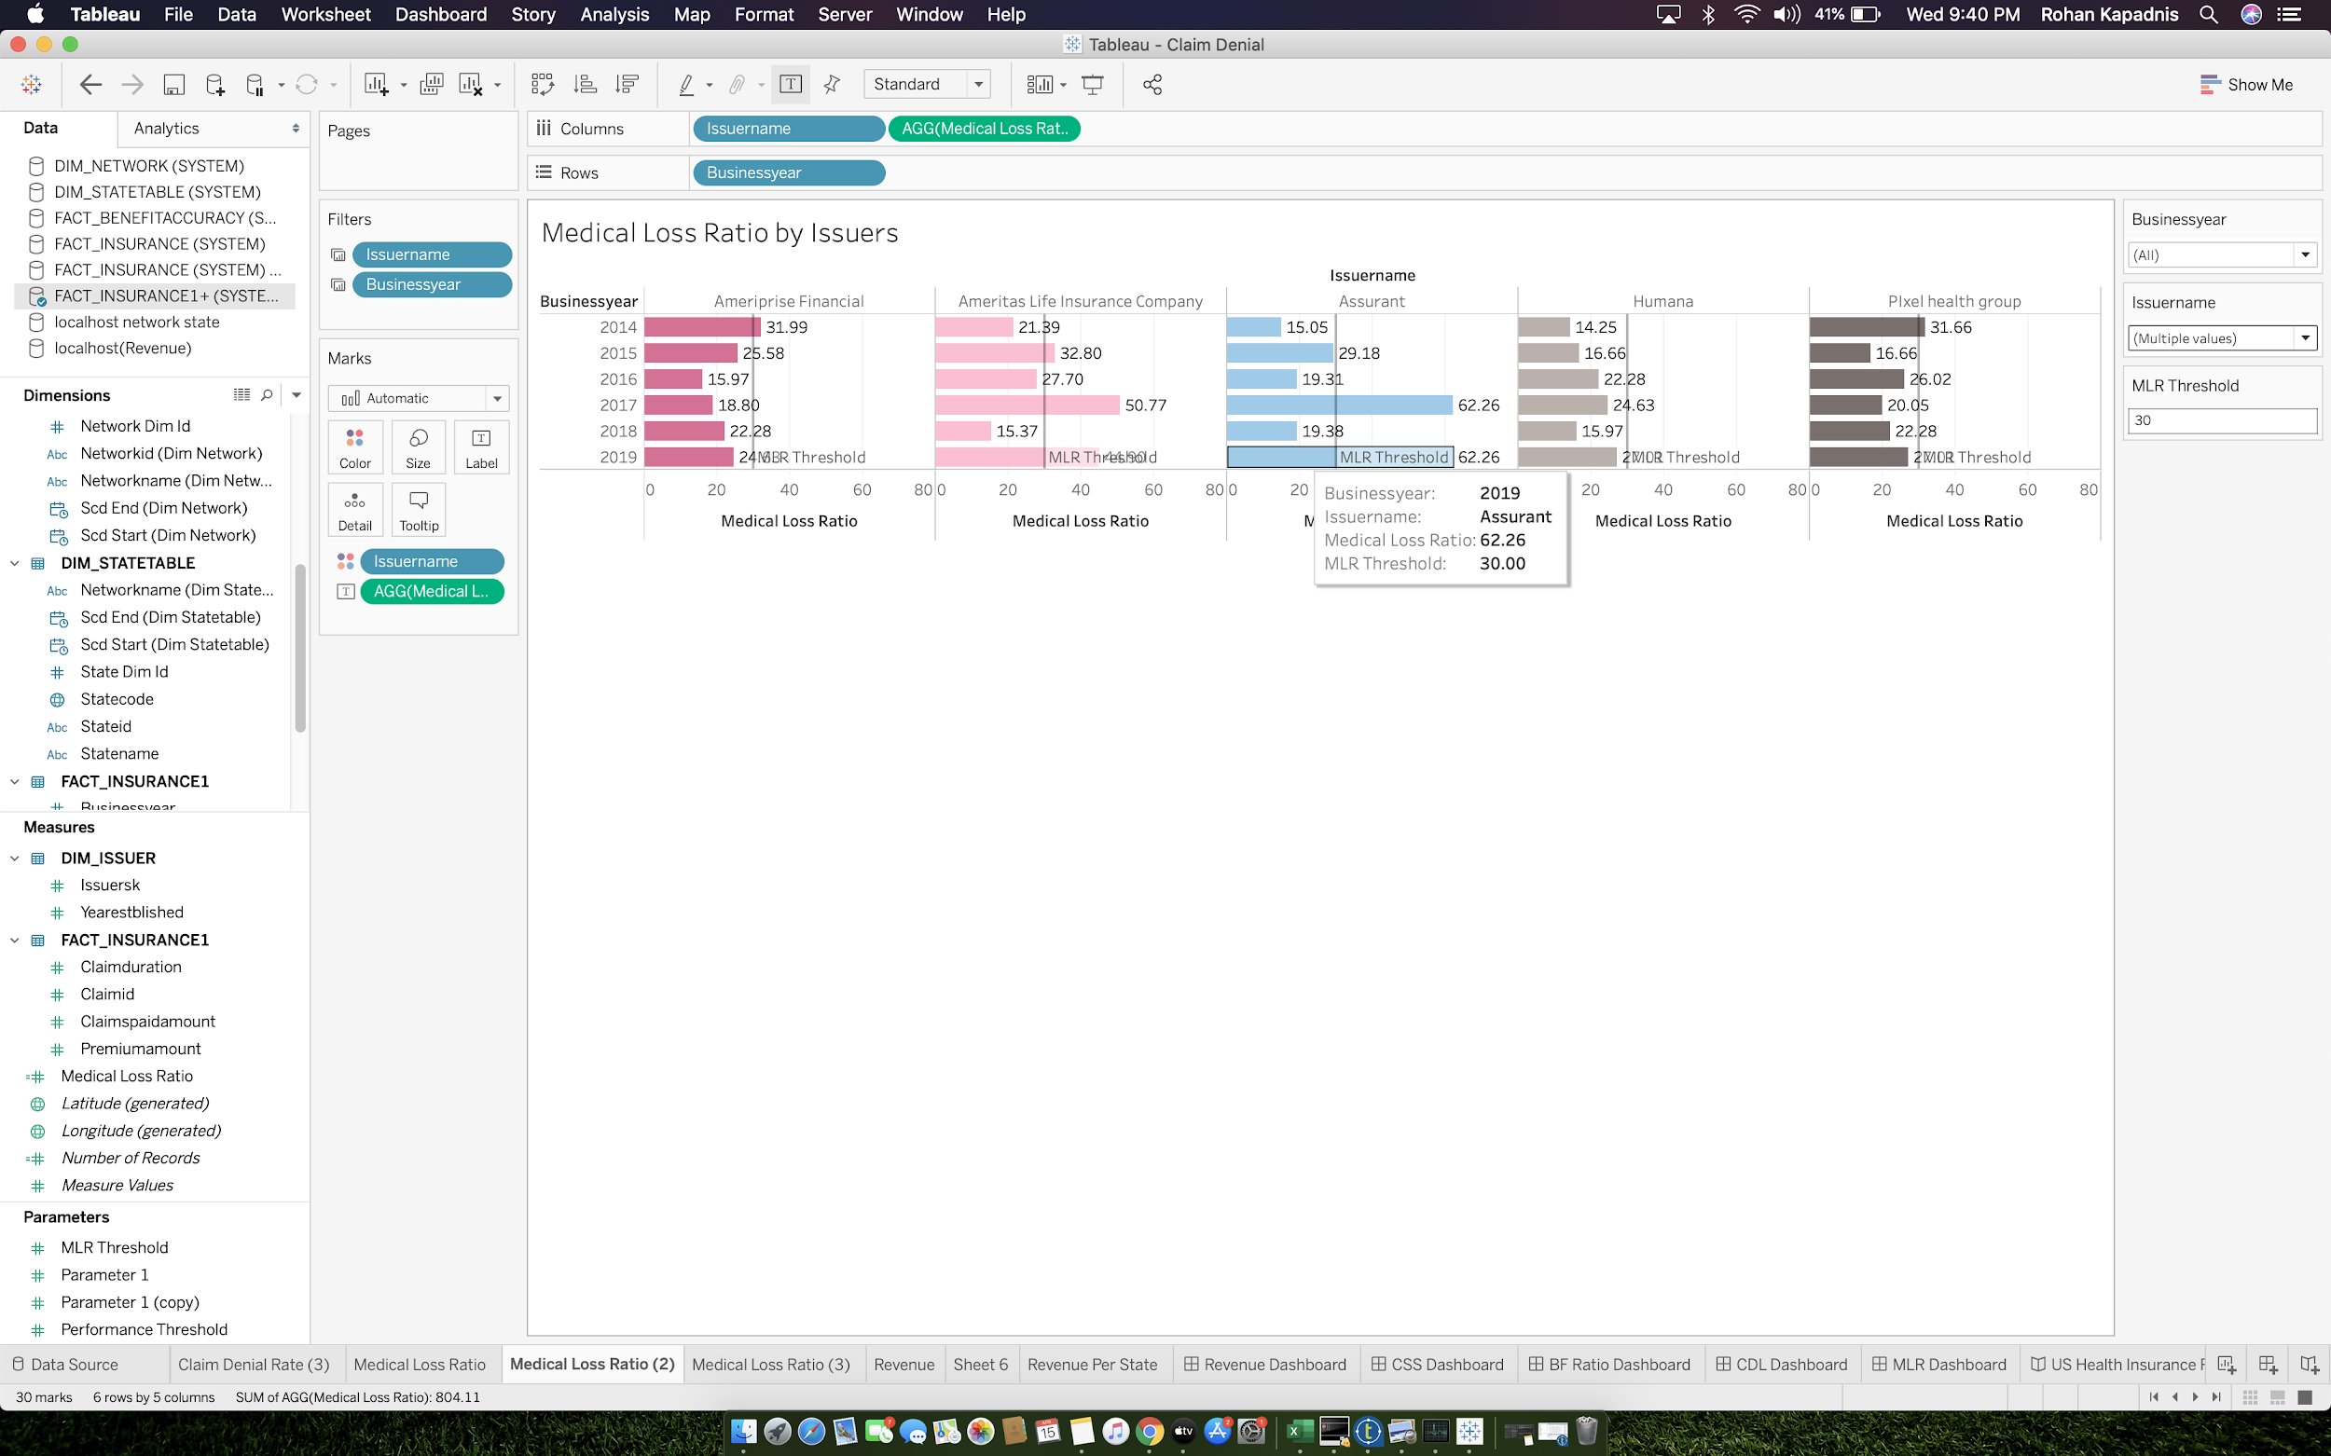

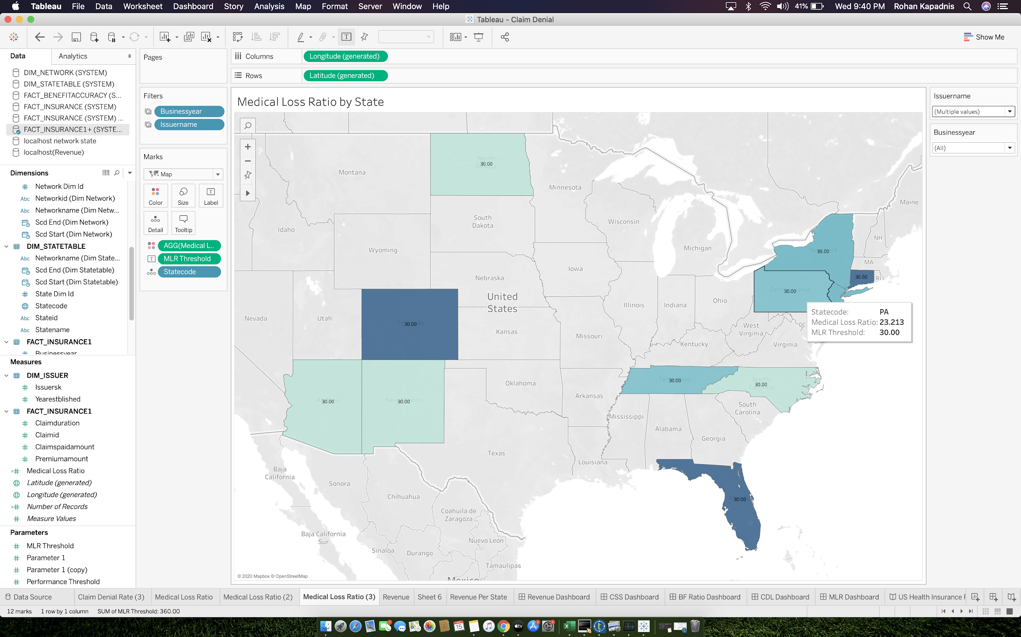

* **E. Revenue SHEETS**

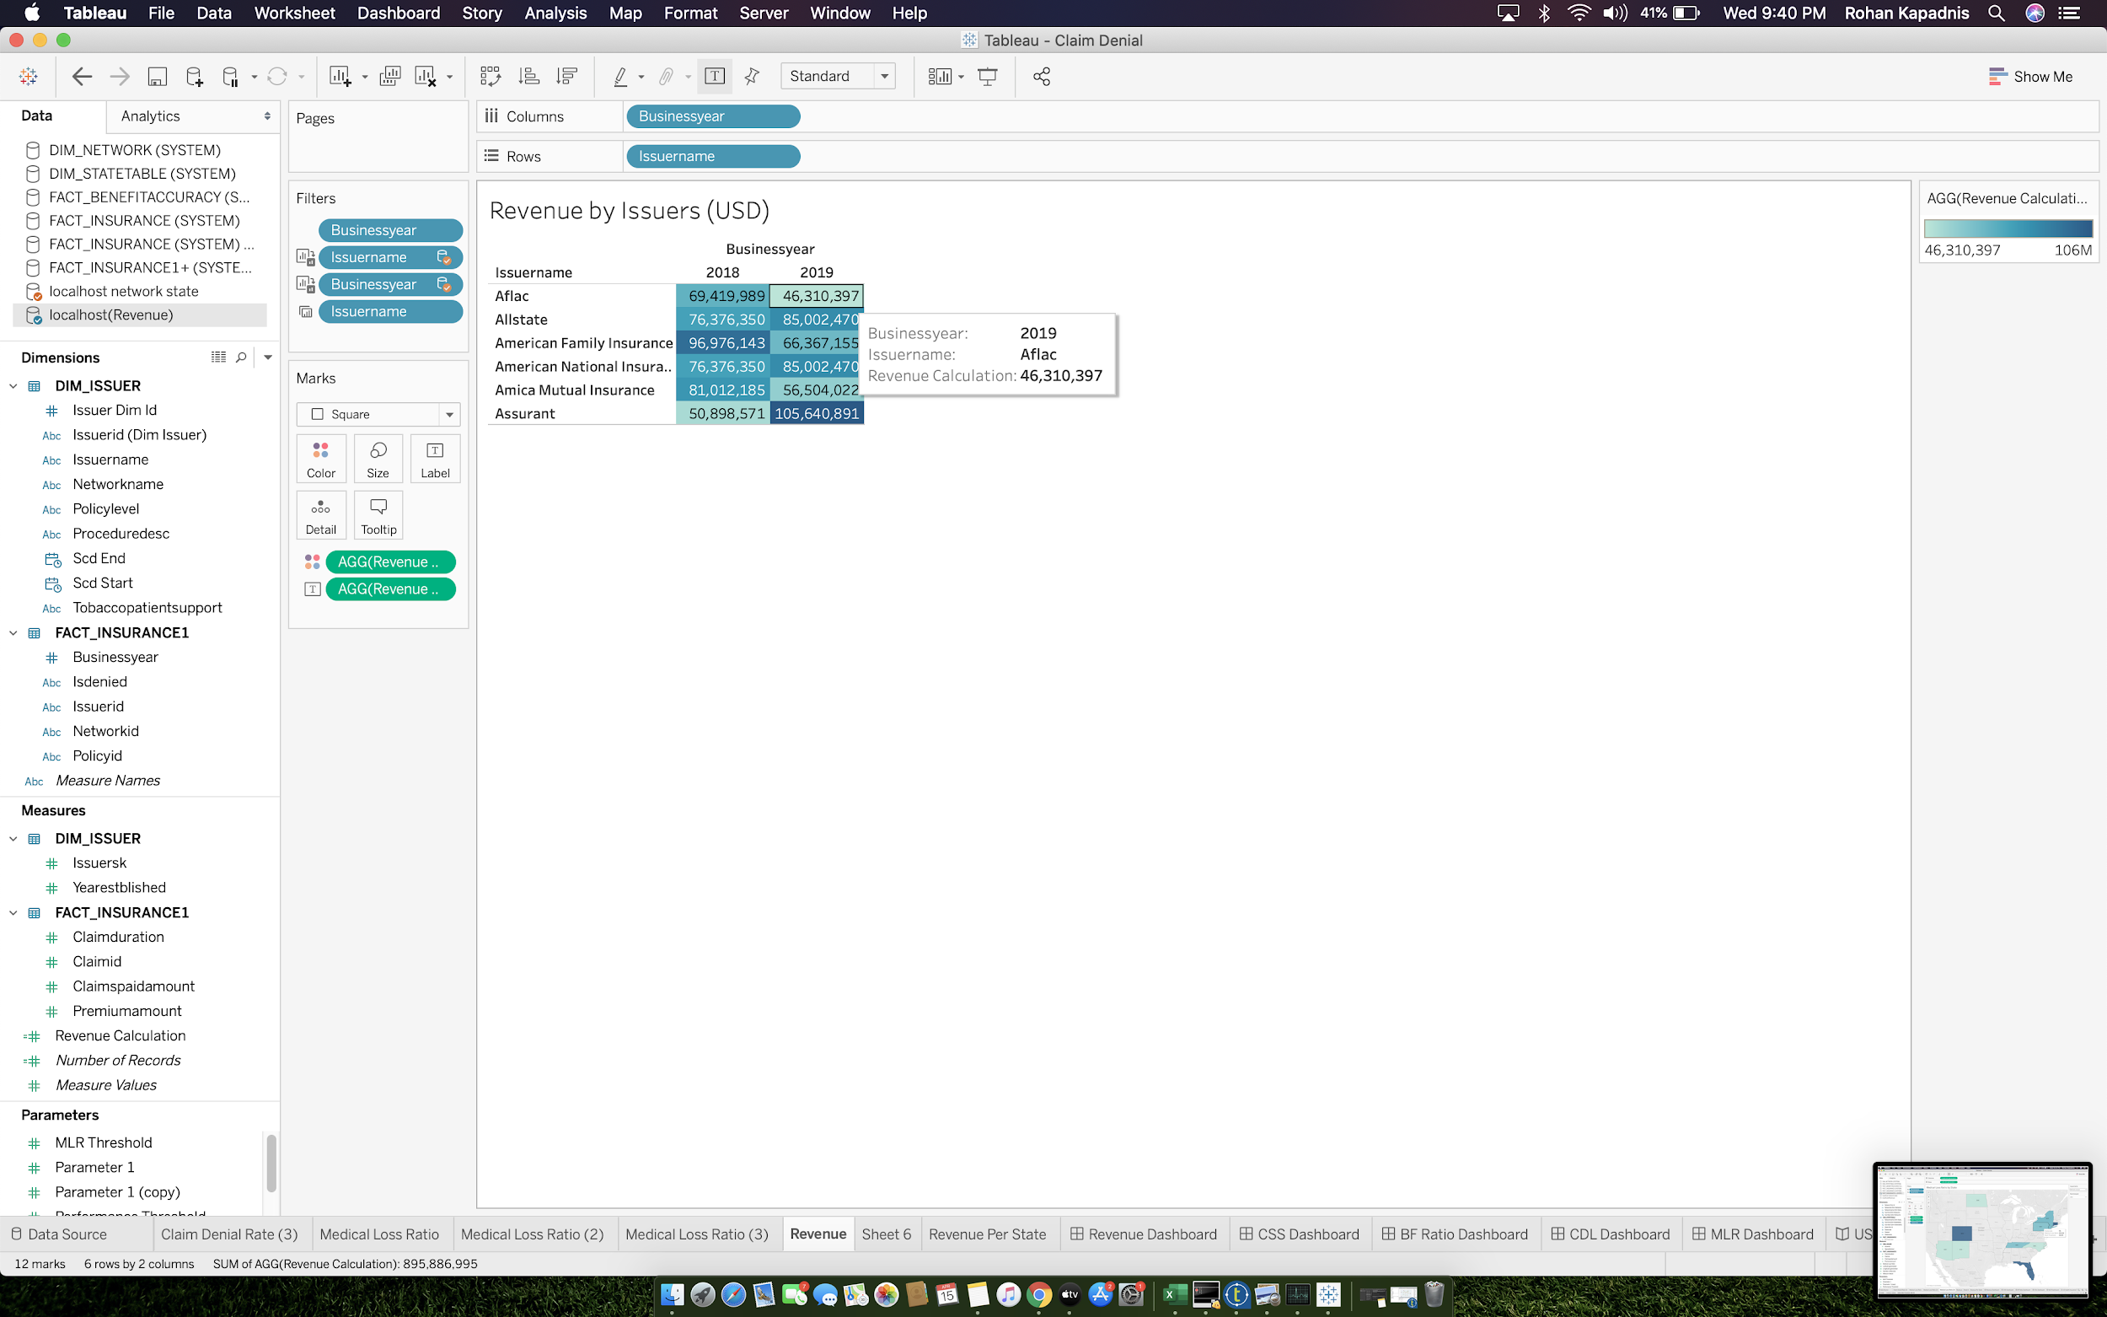

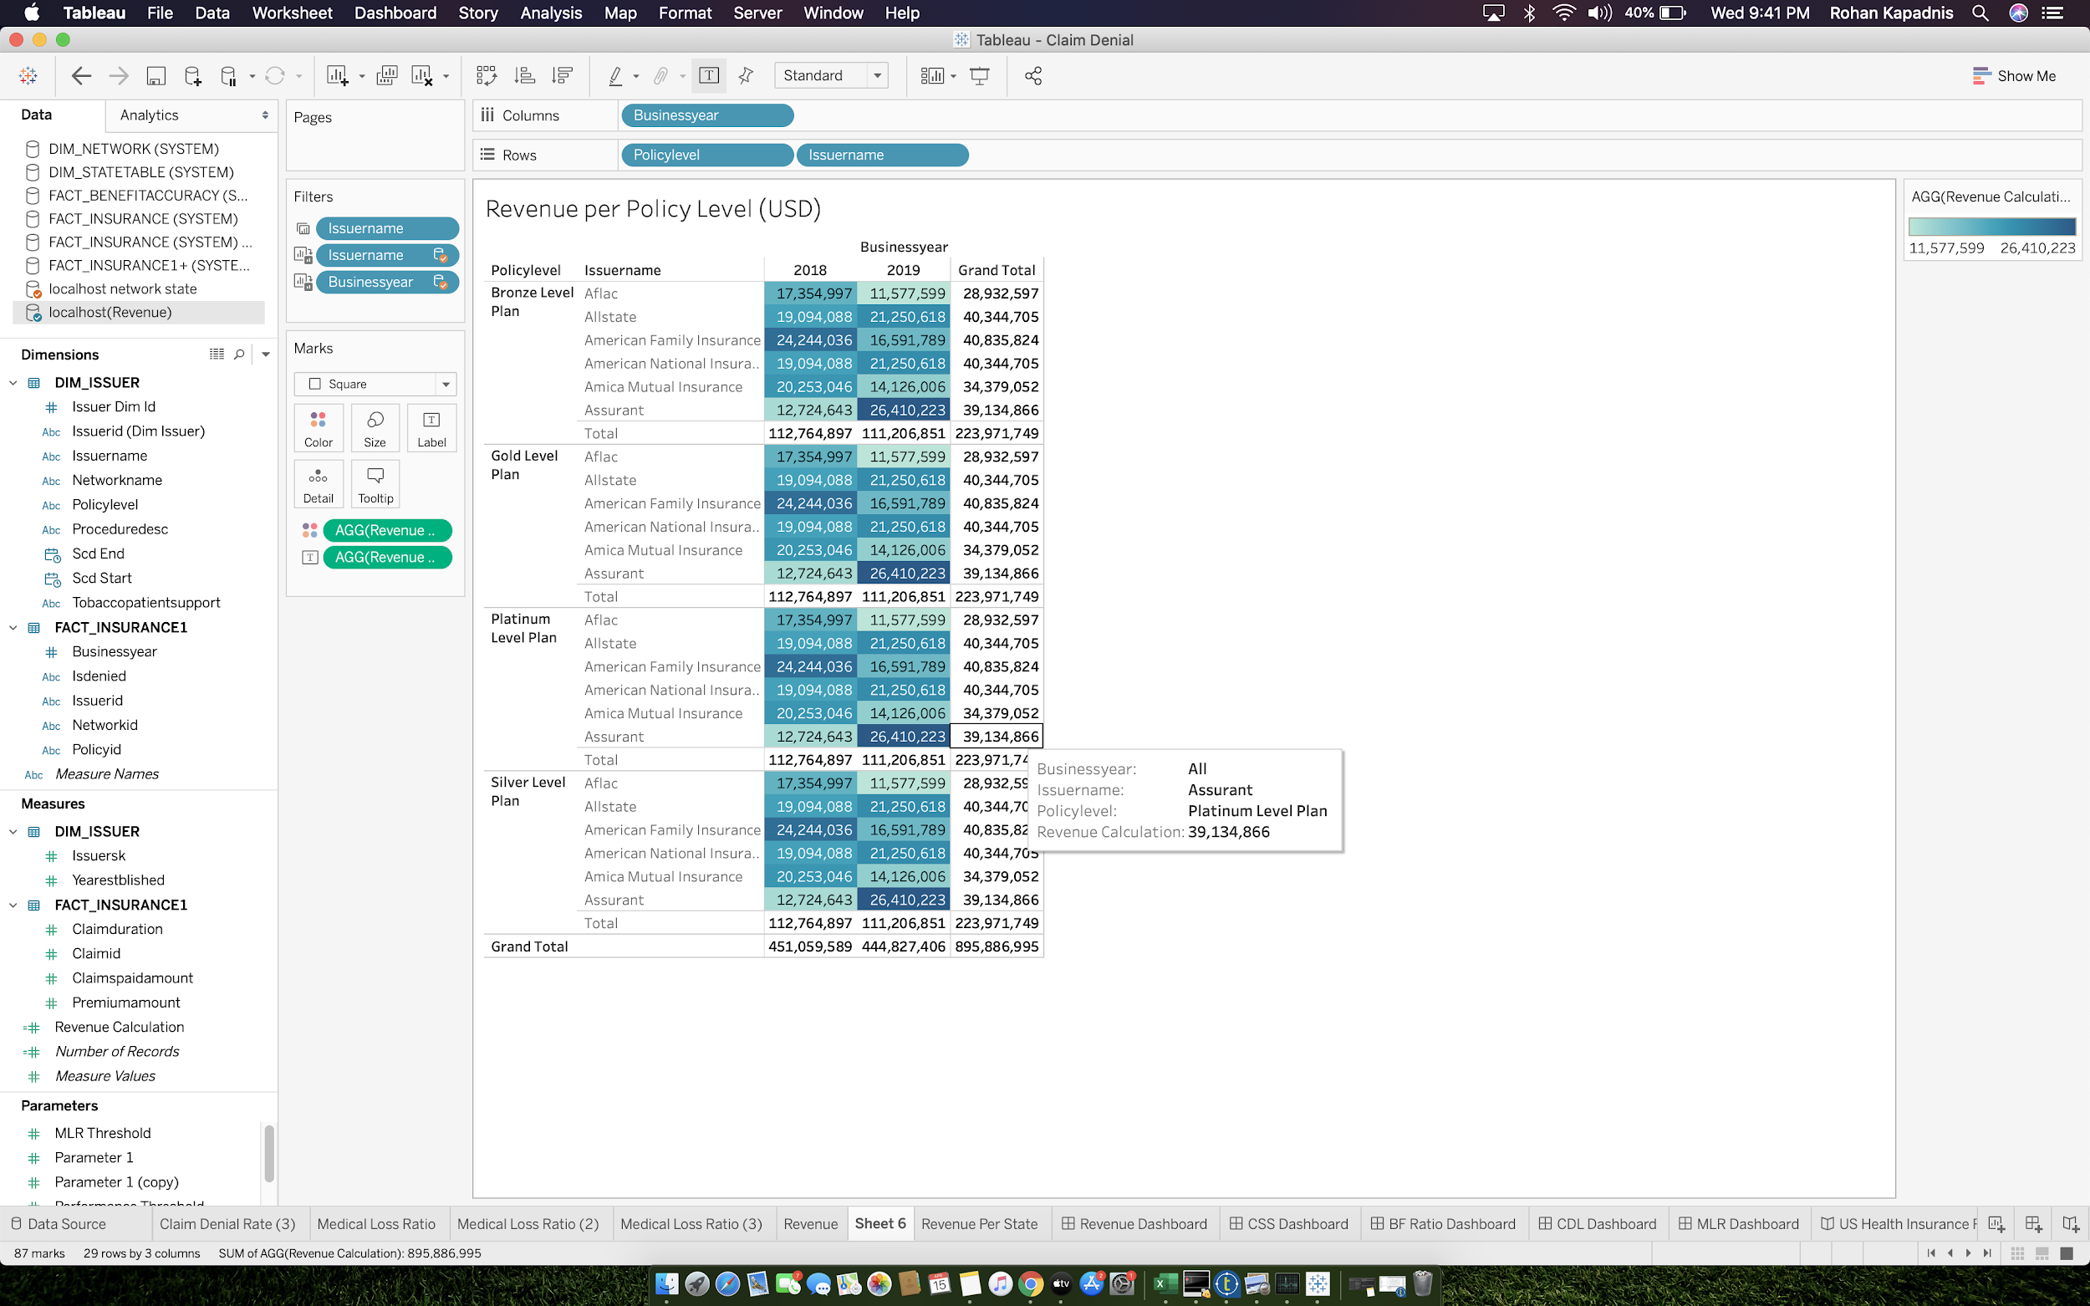

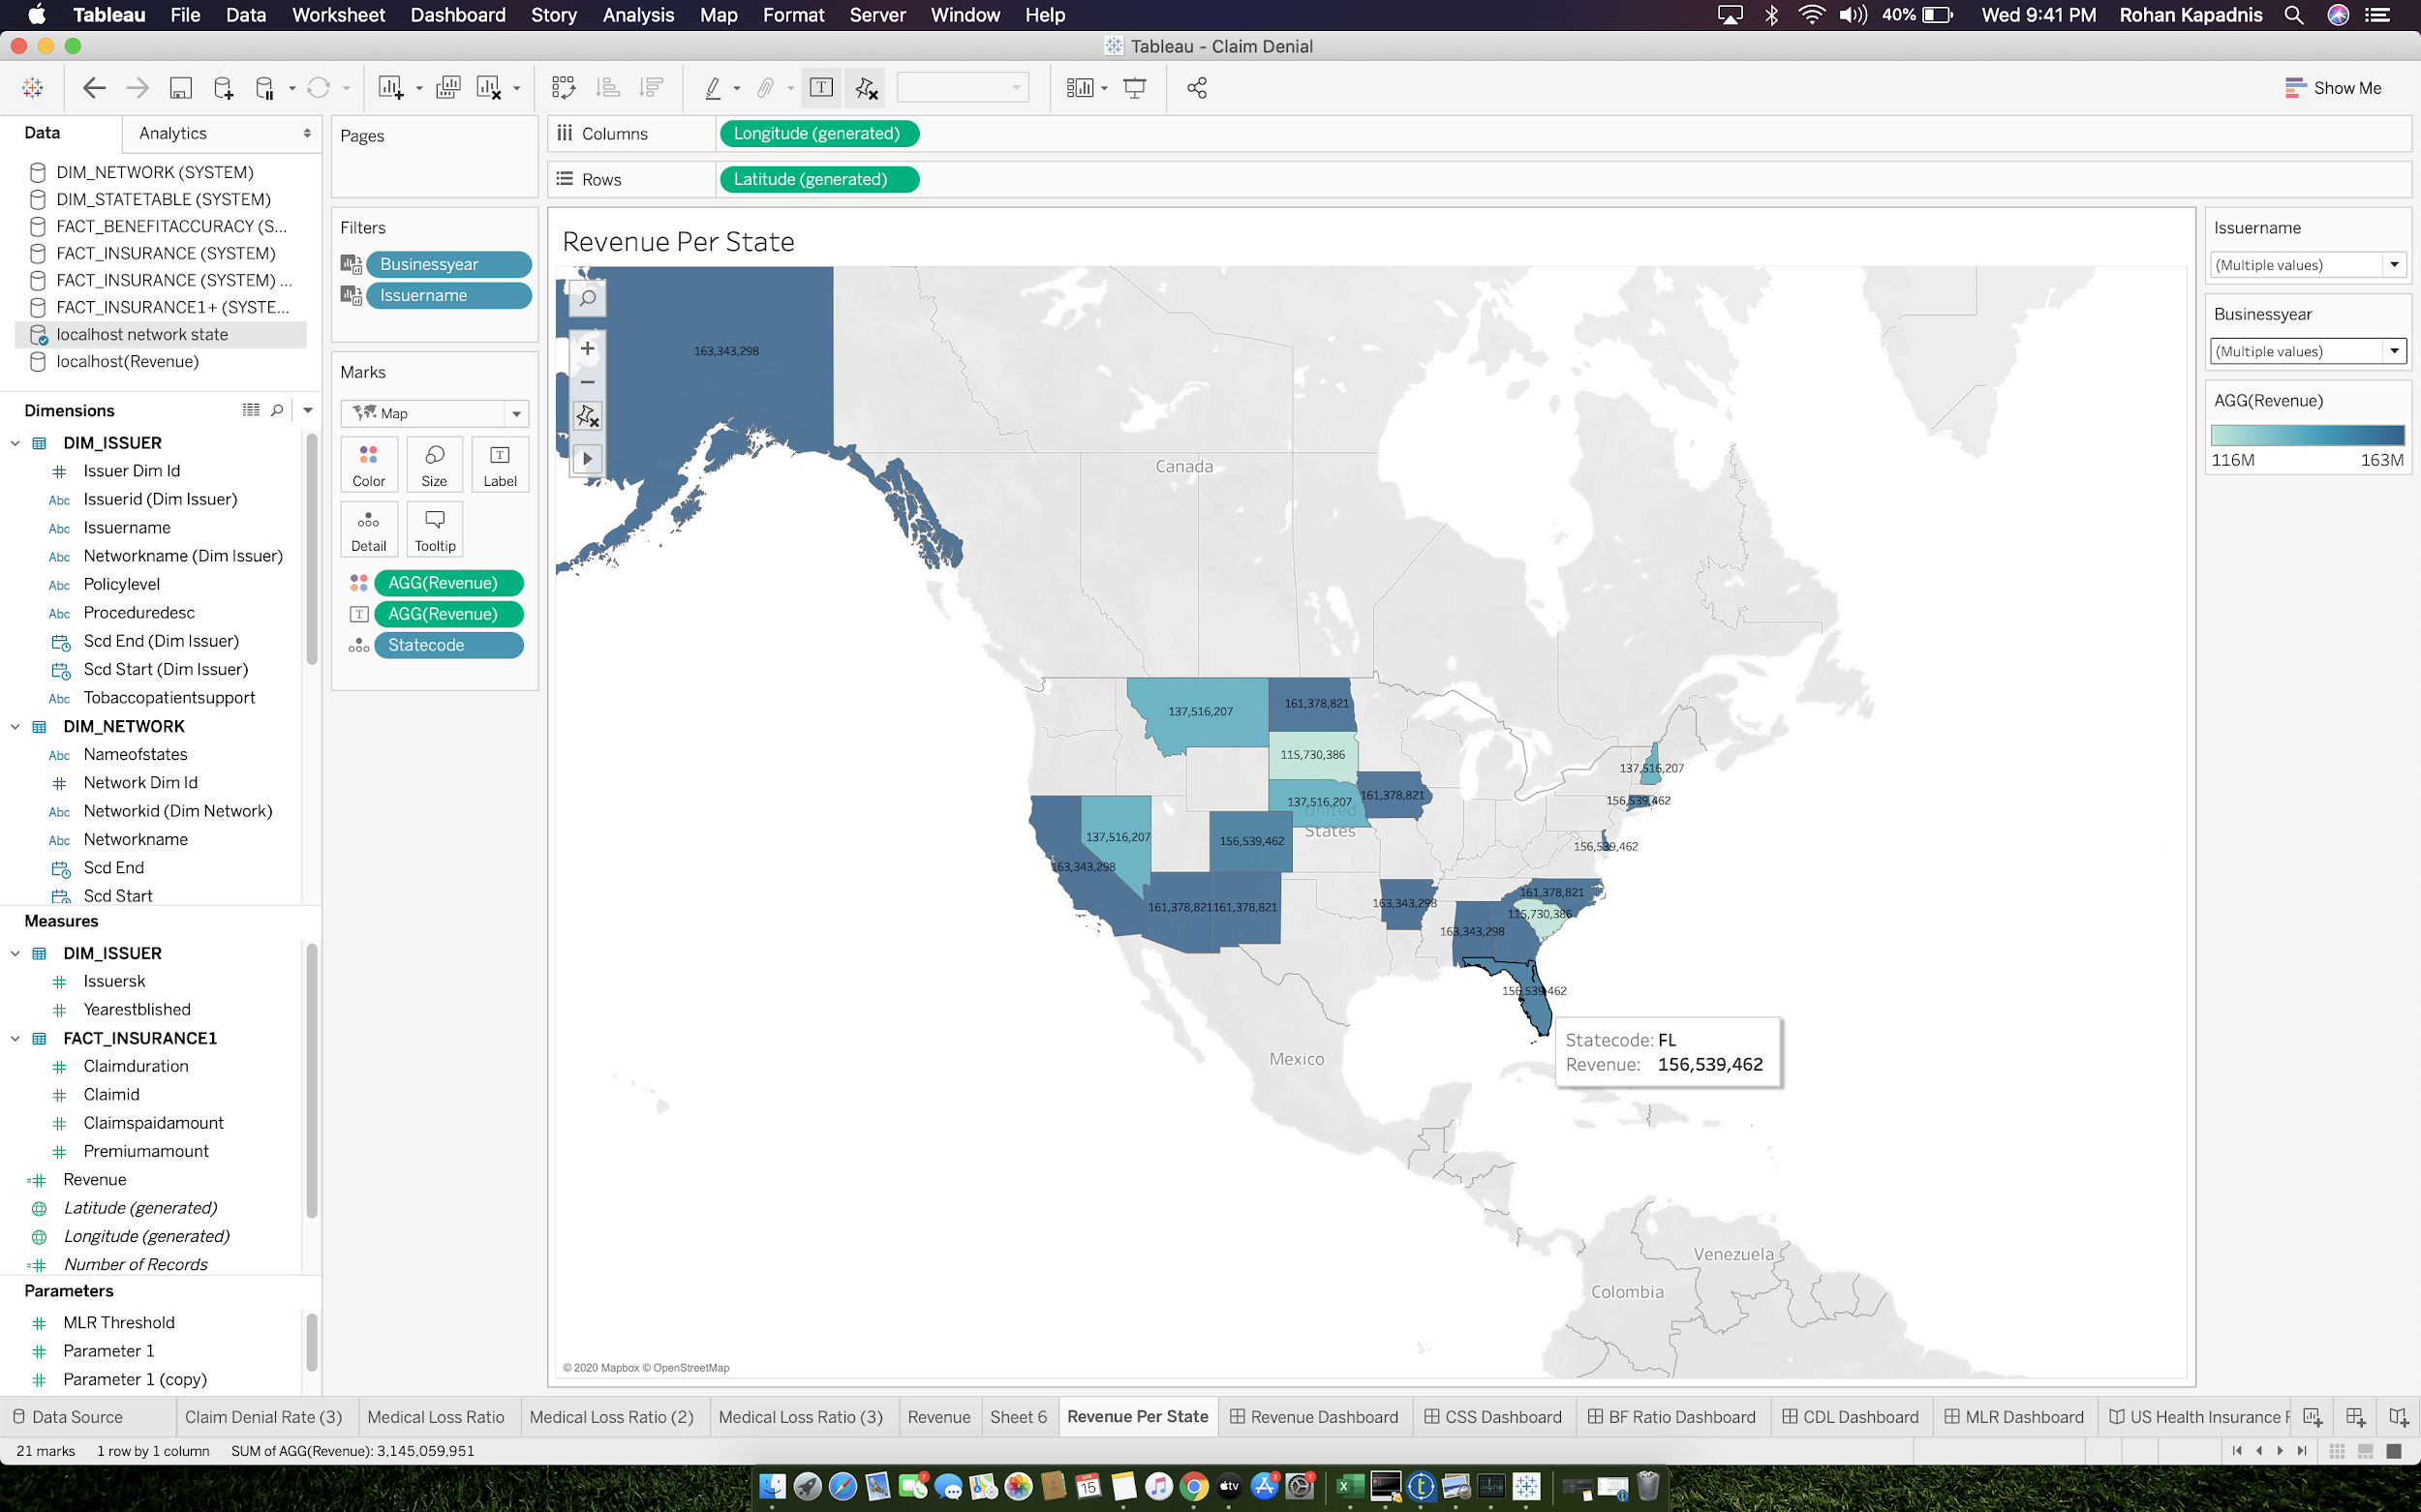

* **F. Revenue DASHBOARD**

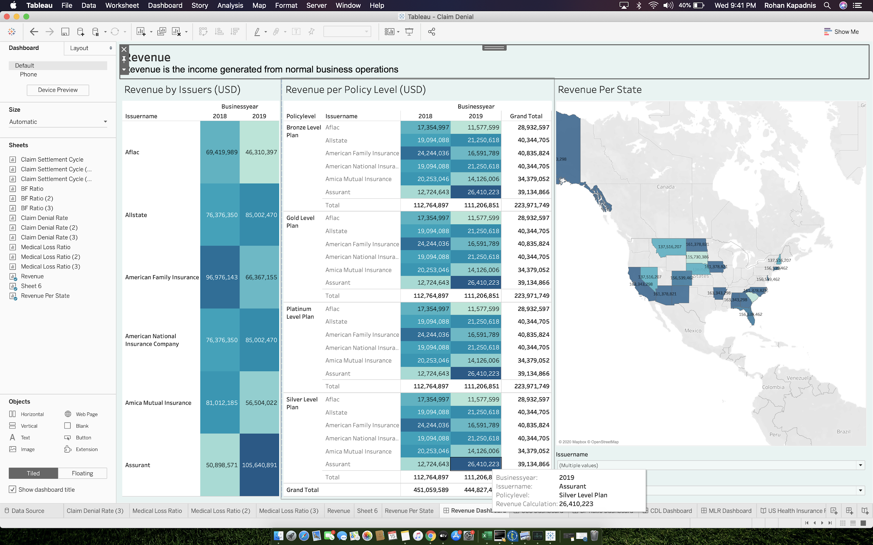

* **G. Claim Settlement Cycle DASHBOARD**

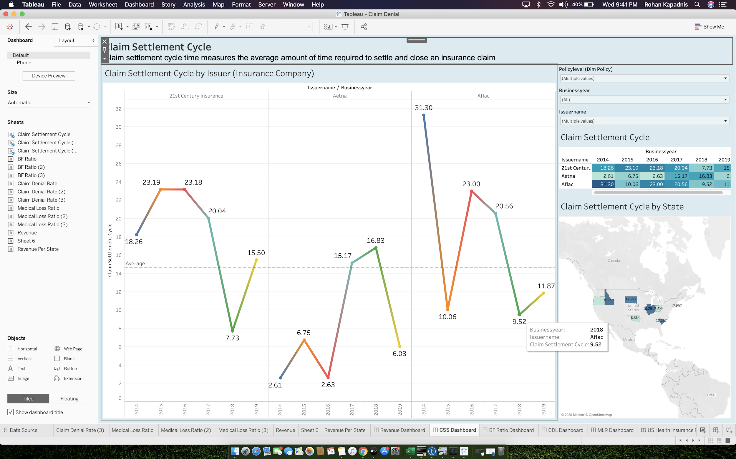

* **H. Benefit Accuracy Rate DASHBOARD**

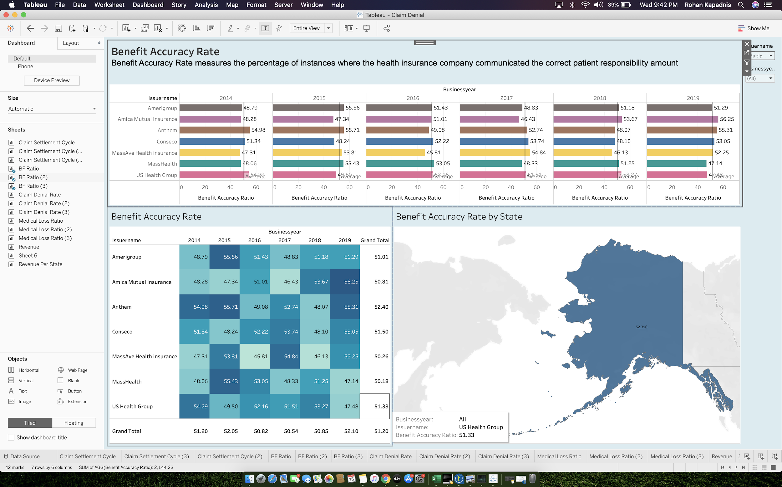

* **I. Claim Denial Rate DASHBOARD**

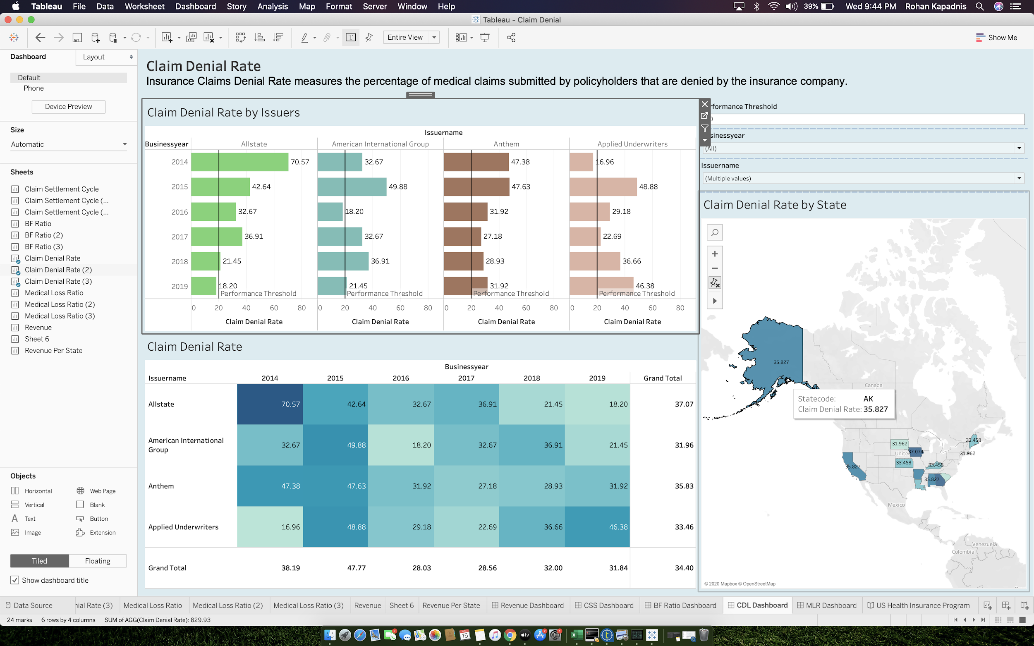

* **J. Medical Loss Ratio DASHBOARD**

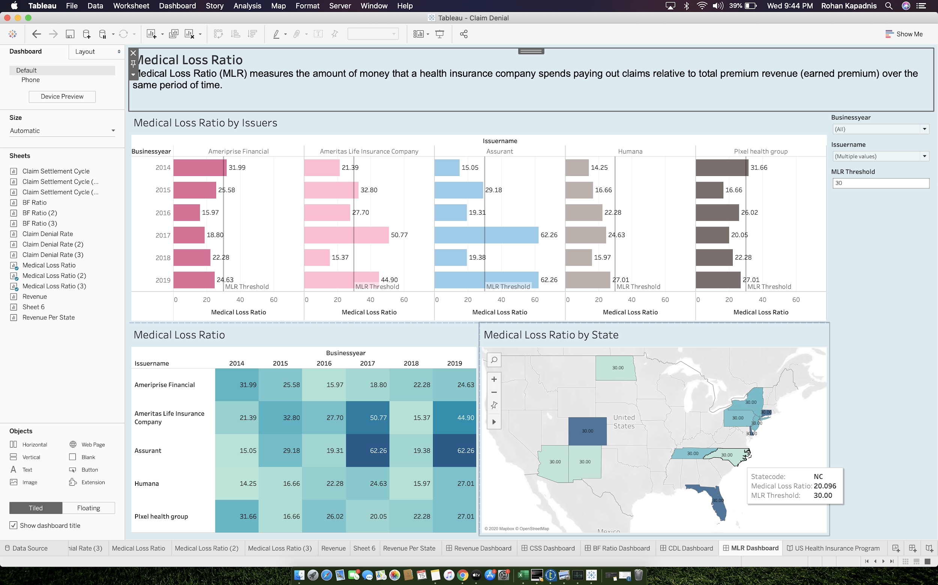

* **K. Medical Loss Ratio Story**

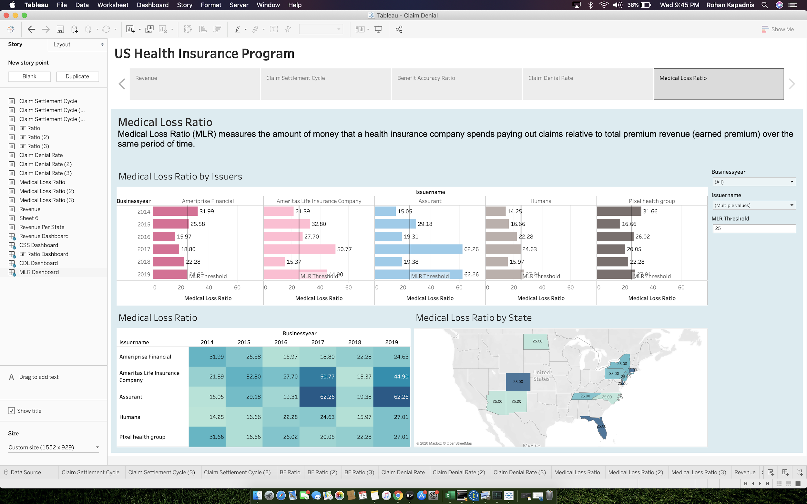

* **L. Claim Denial Rate STORY**

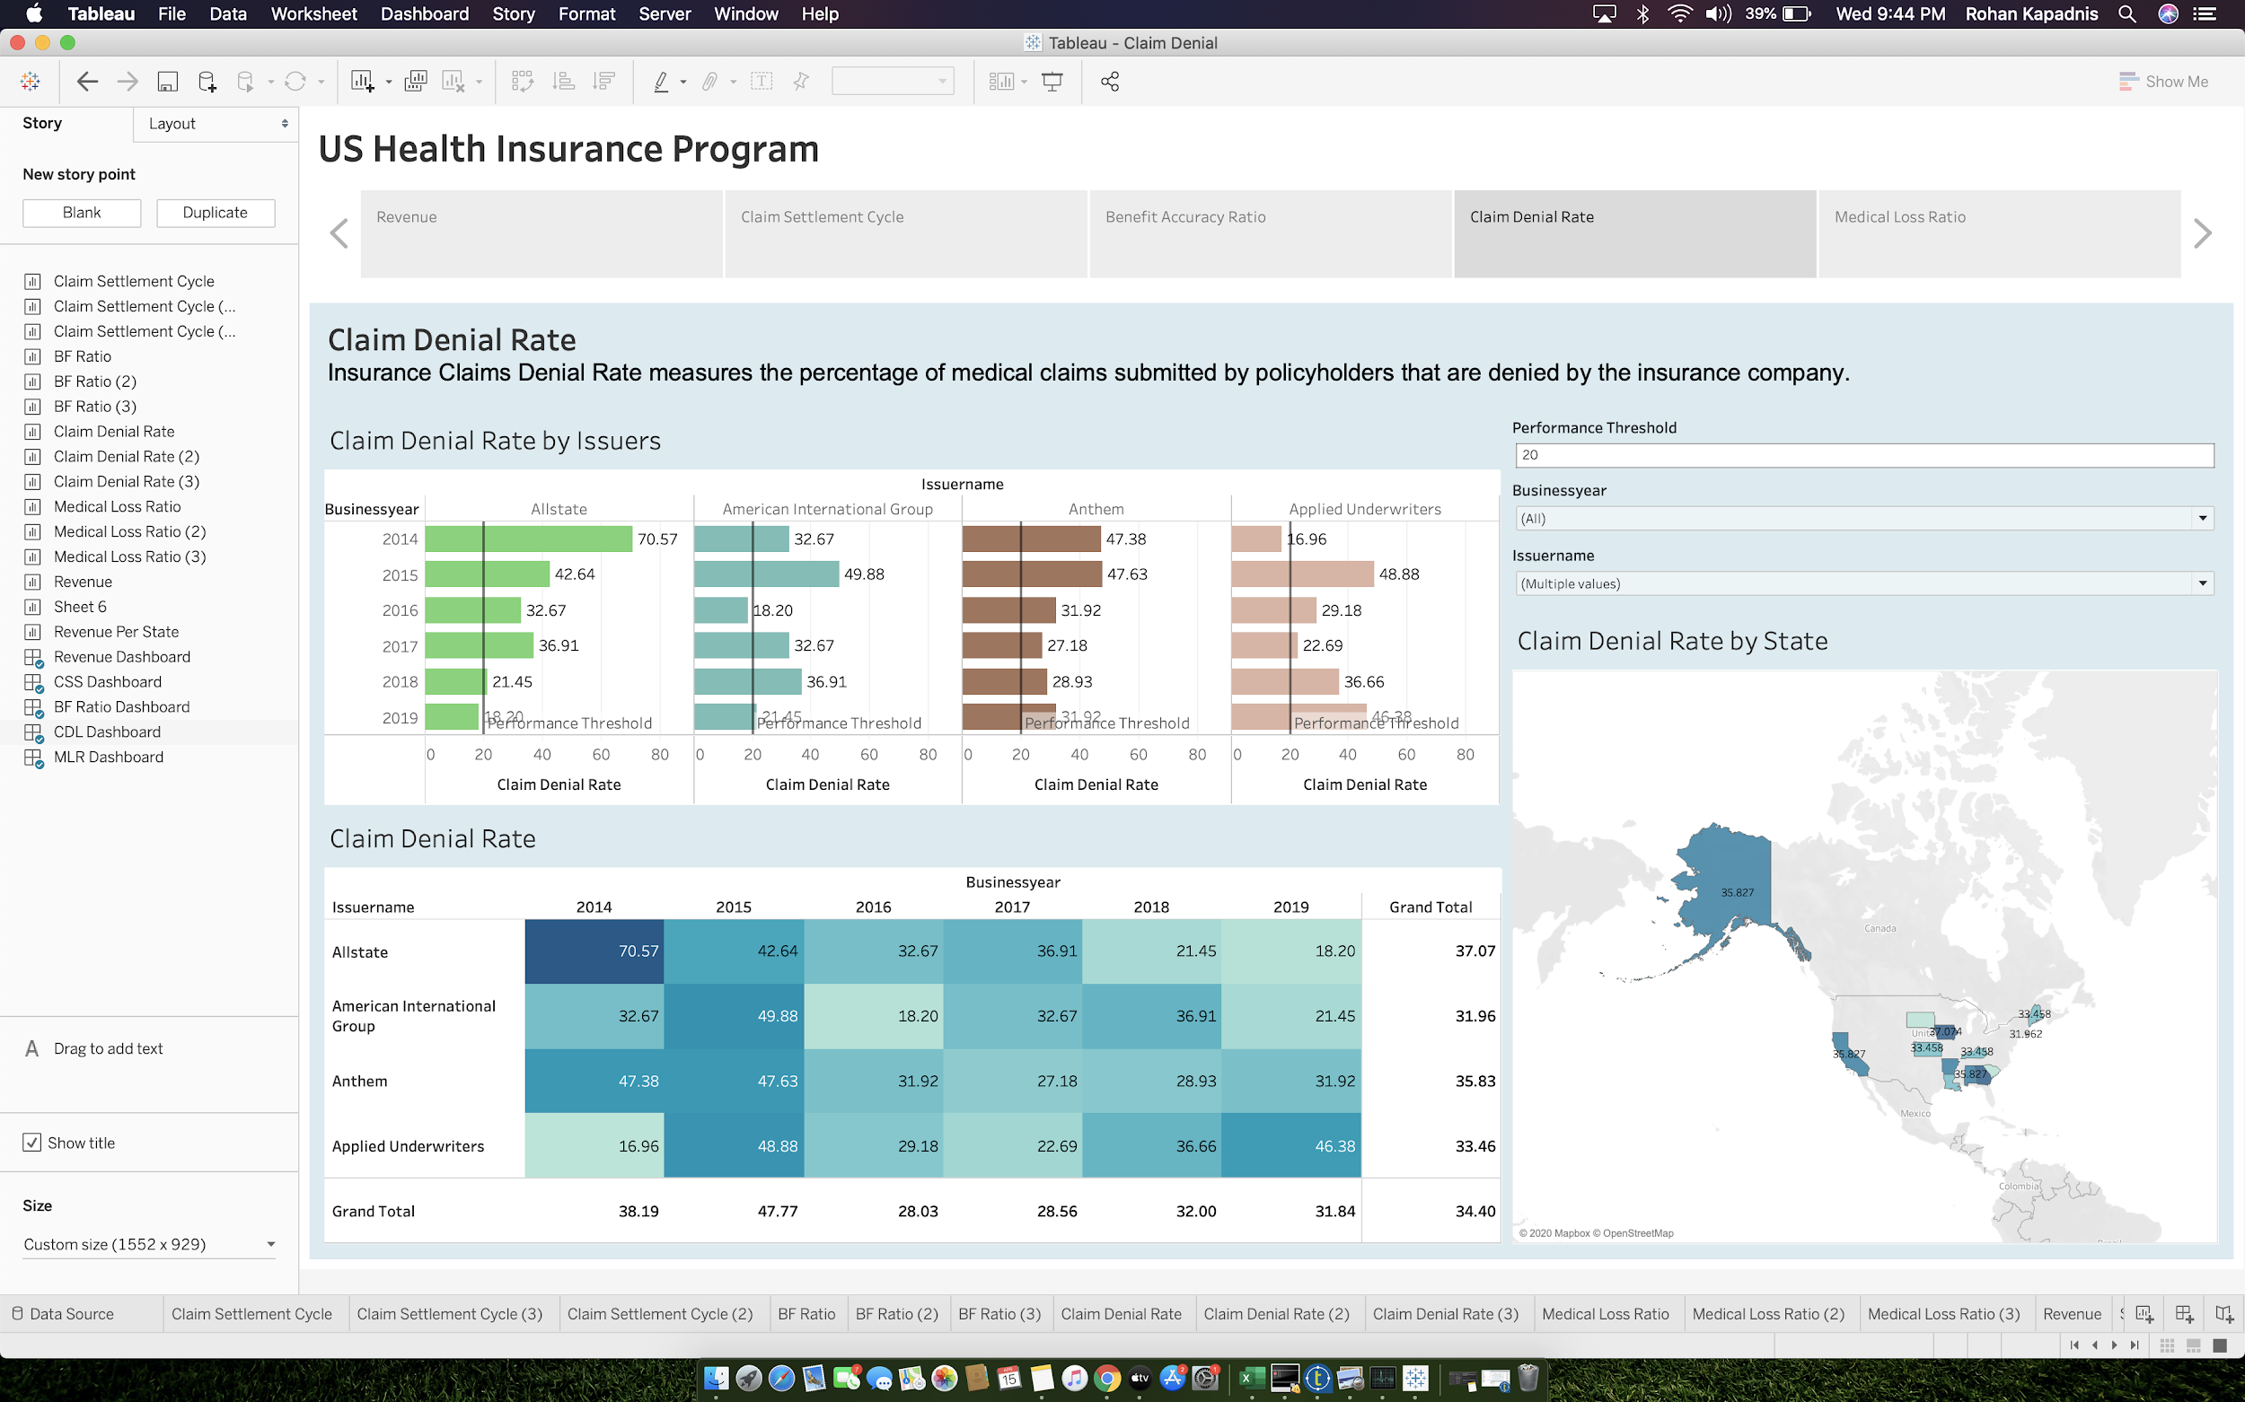

* **M. Benefit Accuracy Rate STORY**

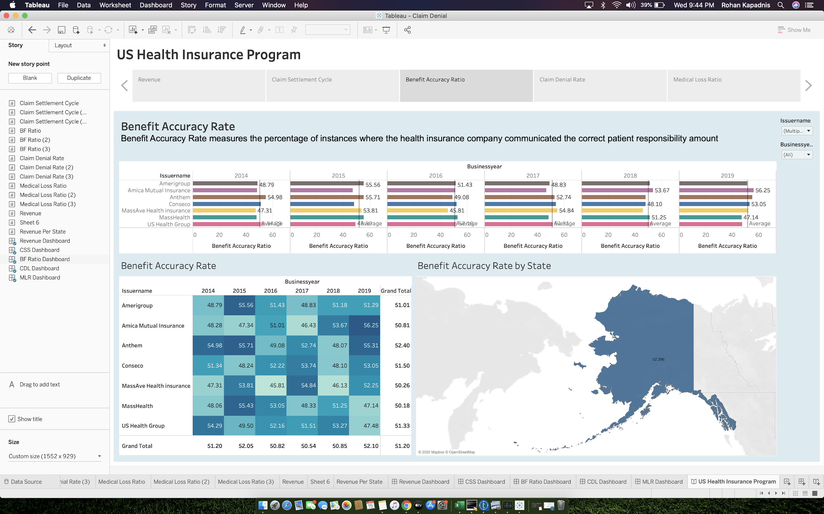

* **N. Claim Settlement Cycle STORY**

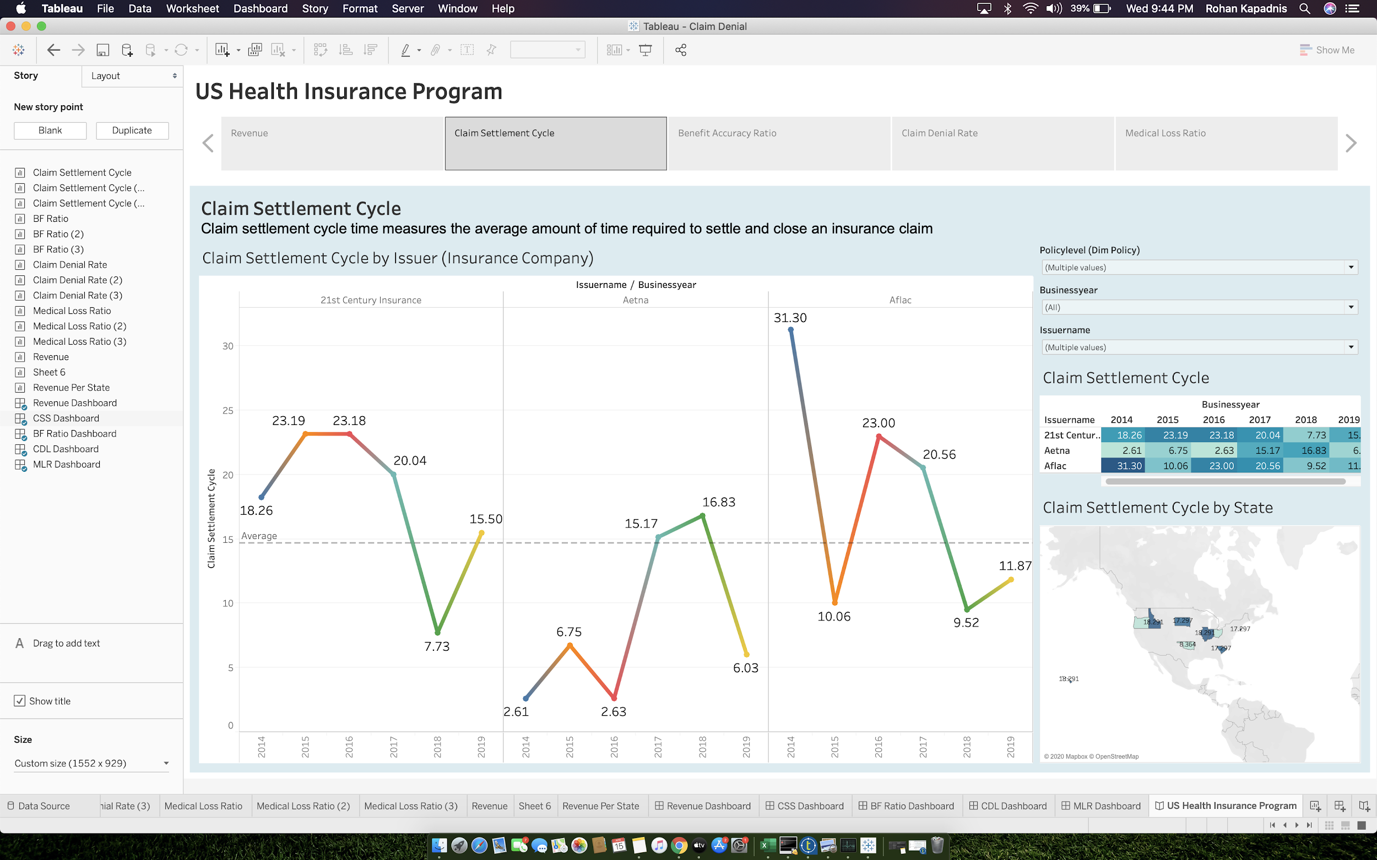

* **O. Revenue STORY**

